SharePoint MFRP Project

Contents

1. Create a Site Collection and Team Site for Sales Portal 2

2. List Specificatons 3

3. Header & Footer (Application Customizer) 5

4. Configure Navigation 8

5. OOB Custom Views 9

6. PowerApps 11

7. Build a SPFx webpart with ReactJS UI 12

8. Create 2 security groups in the site 15

9. Send mail to Sales users using Flow (Power Automate) 18

## 1. Create a Site Collection and Team Site for Sales Portal

Go to SharePoint Admin Center -> Sites -> +Create -> Team Site

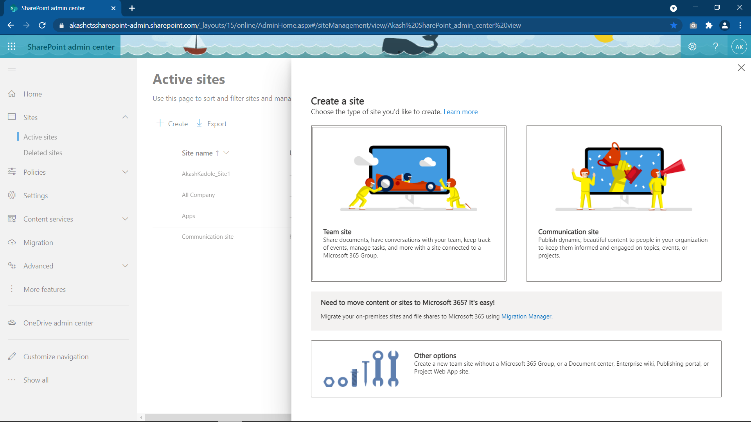

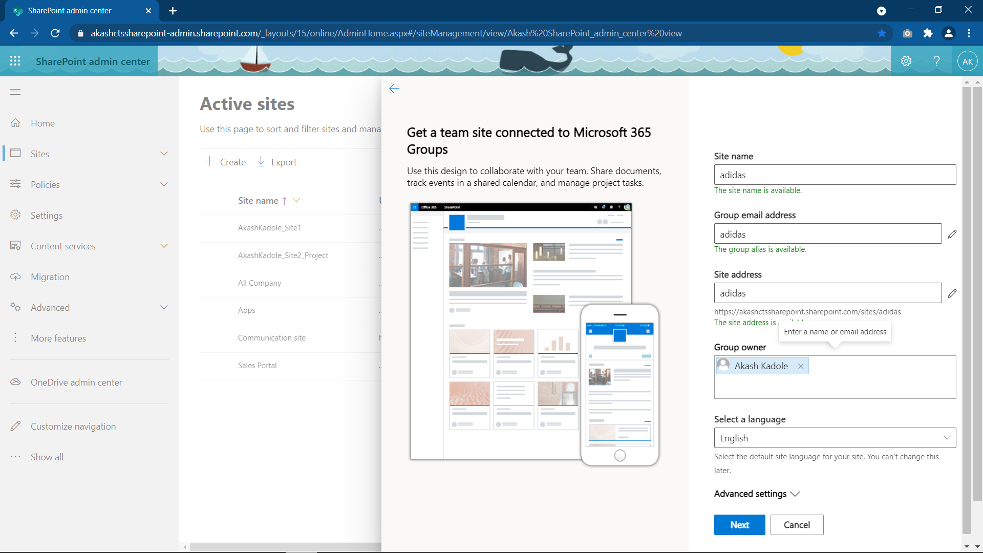

## 2. List Specificatons

Customers List : All columns required

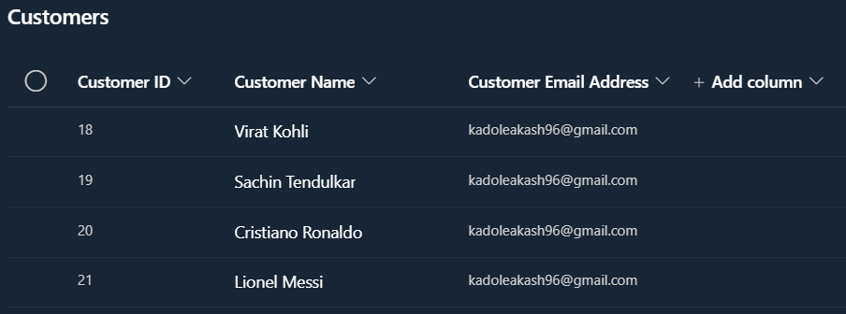

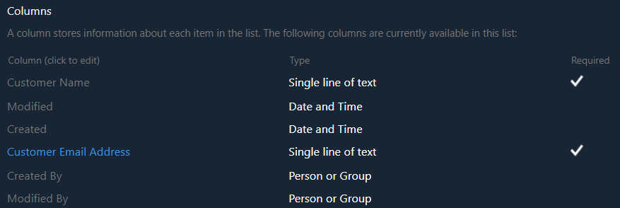

Products List : All columns required

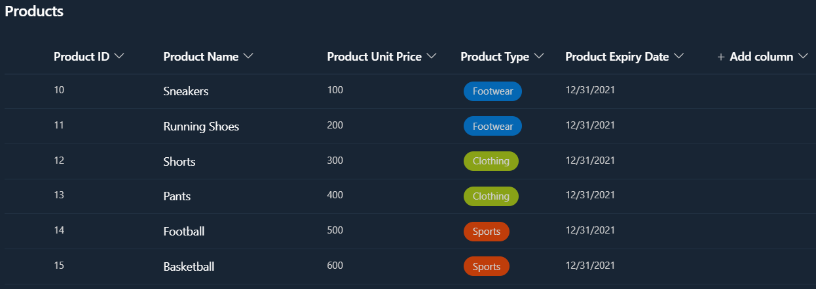

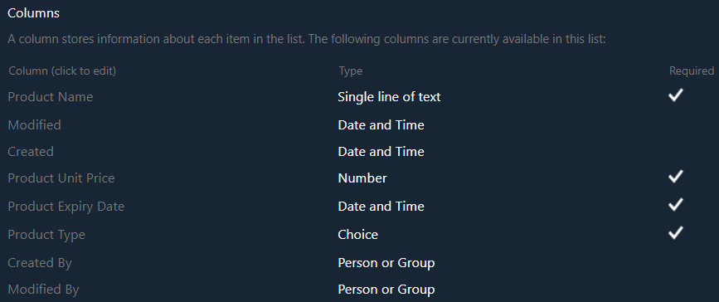

Orders List : All columns required

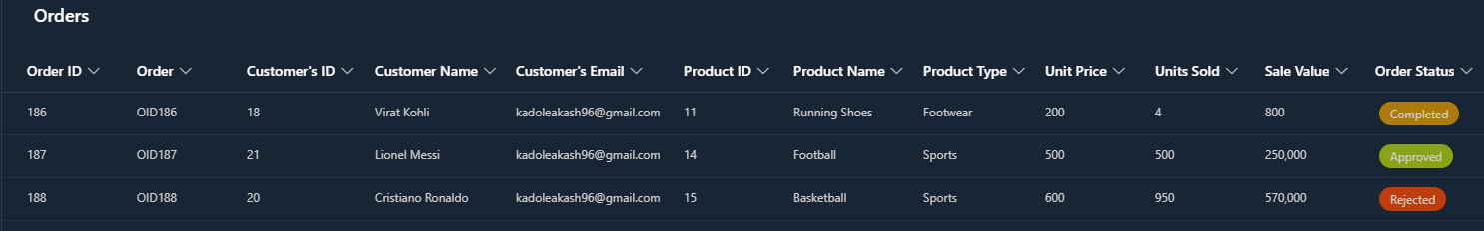

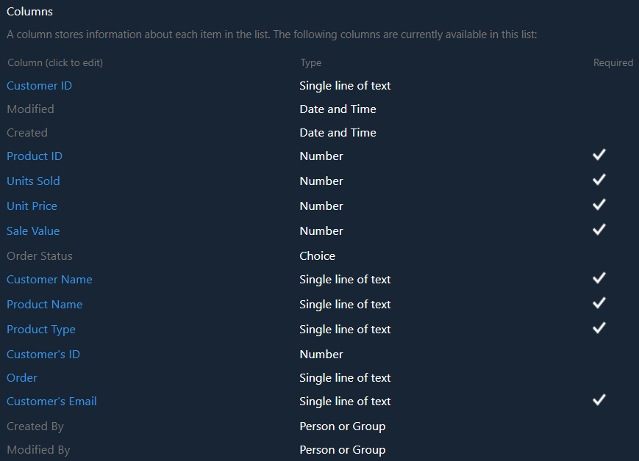

## 3. Design the Homepage with customization with Header & Footer (Application Customizer)

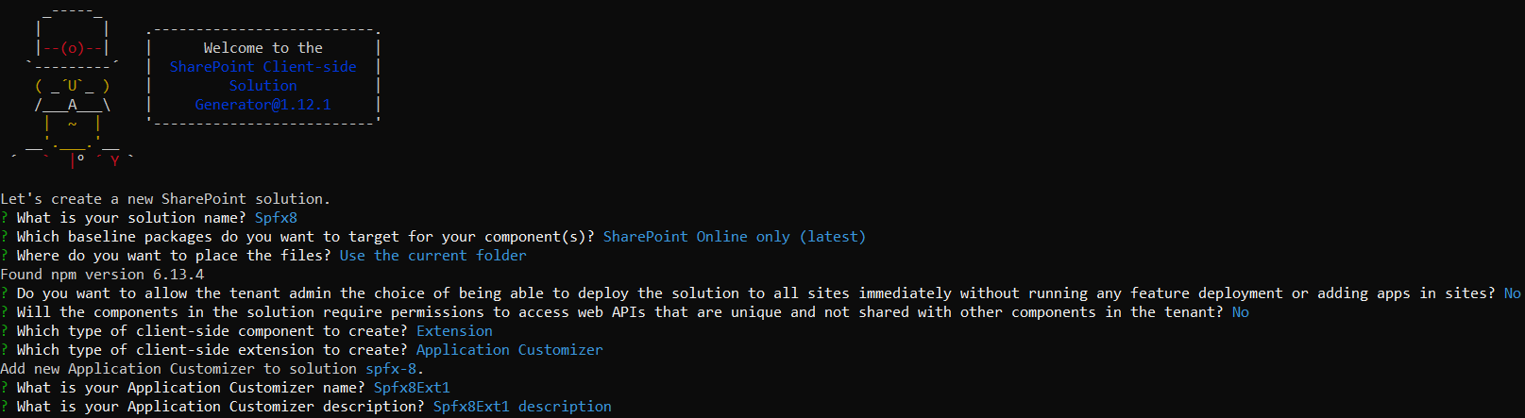

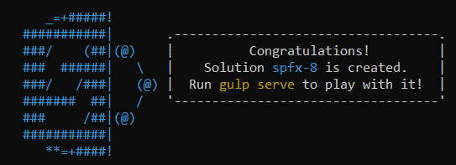

After sometimes, we can see that the SPFx application extension project – scaffolding is completed.

Now open the solution in the VScode and in file Spfx6 -> config -> serve.json ,and change the page URL to your site page

SPFx extensions cannot be tested against local work bench, you would need to test it against live SP online site. But Microsoft has provided a way to debug and test it against live site without going through deployment process(of app catalog).

Now run command gulp serve it will open the url page and not the local workbench(does not supports extenstions)

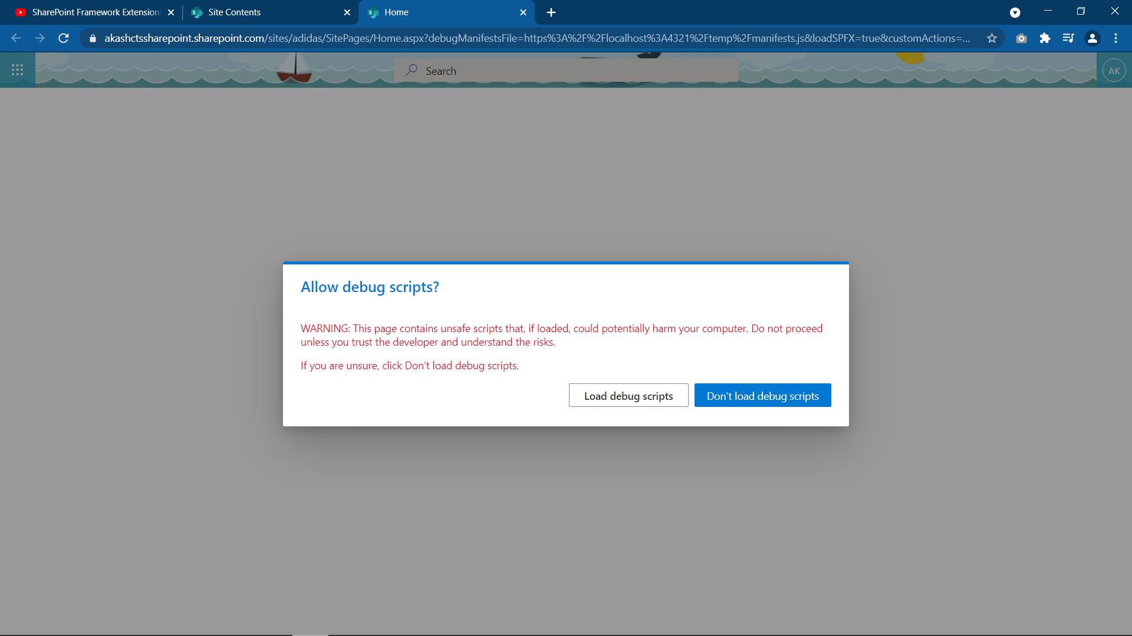We can see our ApplicationCustomizer being executed

Now we can code in Spfx6Ext1ApplicationCustomizer.ts file

After the code, run the solution by gulp serve 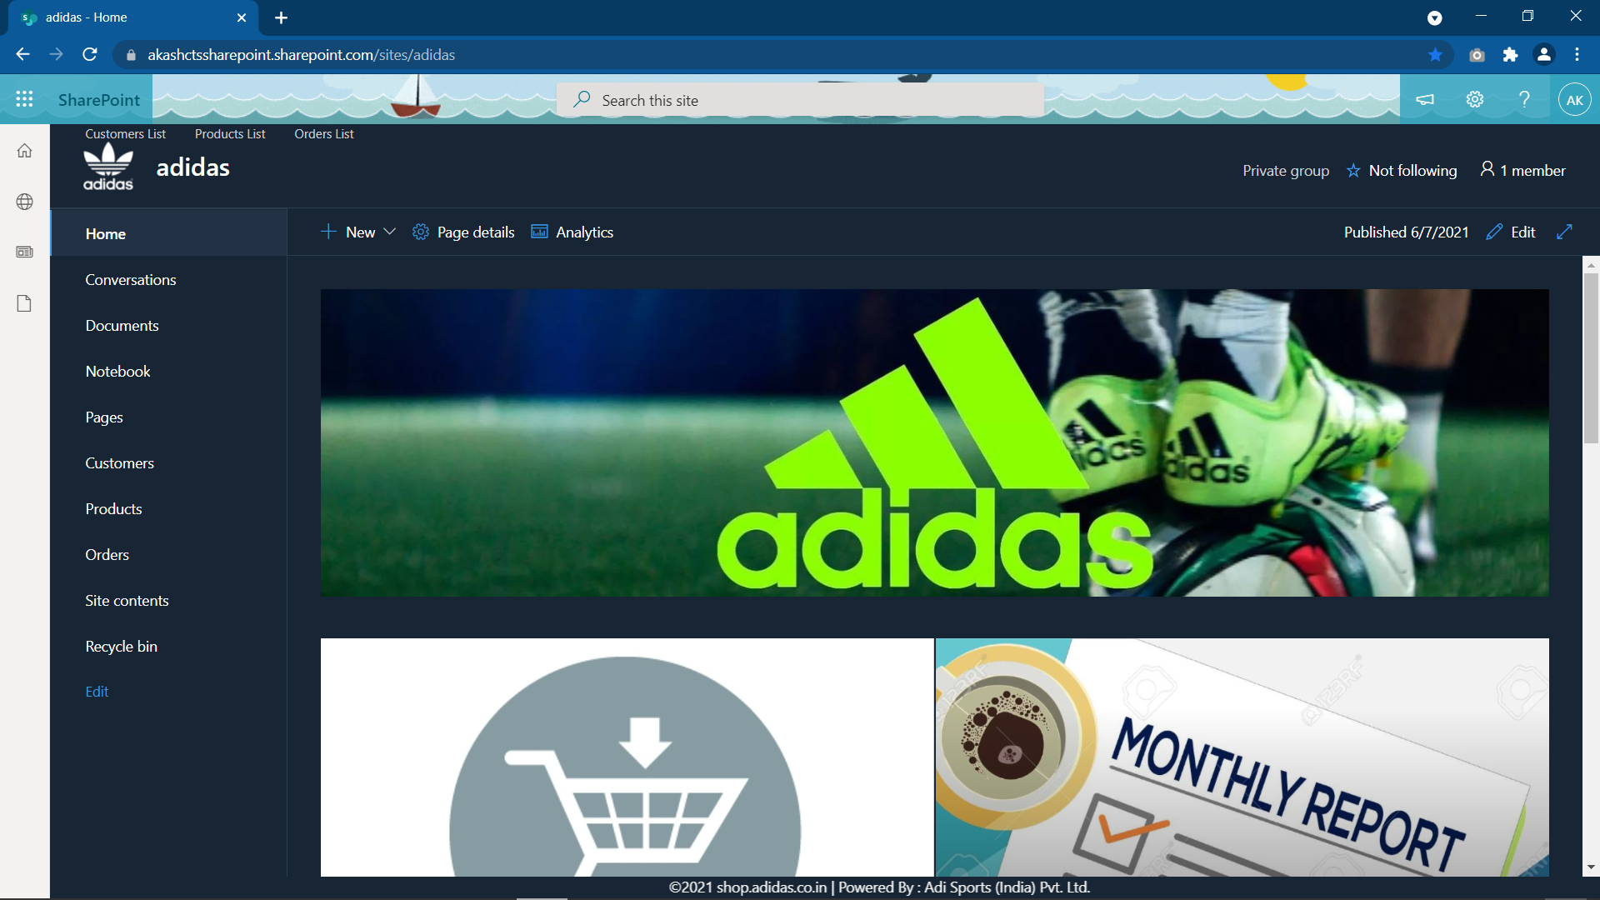

After fully testing in the workbench we can deploy the webpart

Deploying Phase :

to deploy the webpart run the 4 gulp commands in given sequence

gulp clean , gulp build , gulp bundle --ship , gulp package-solution --ship to create .sppkg file

Now a .sppkg file has been created within the folder ./sharepoint/solution/spfx-3.sppkg

Now go to your SharePoint Admin Canter -> More Features -> Apps(open) -> App Catalog

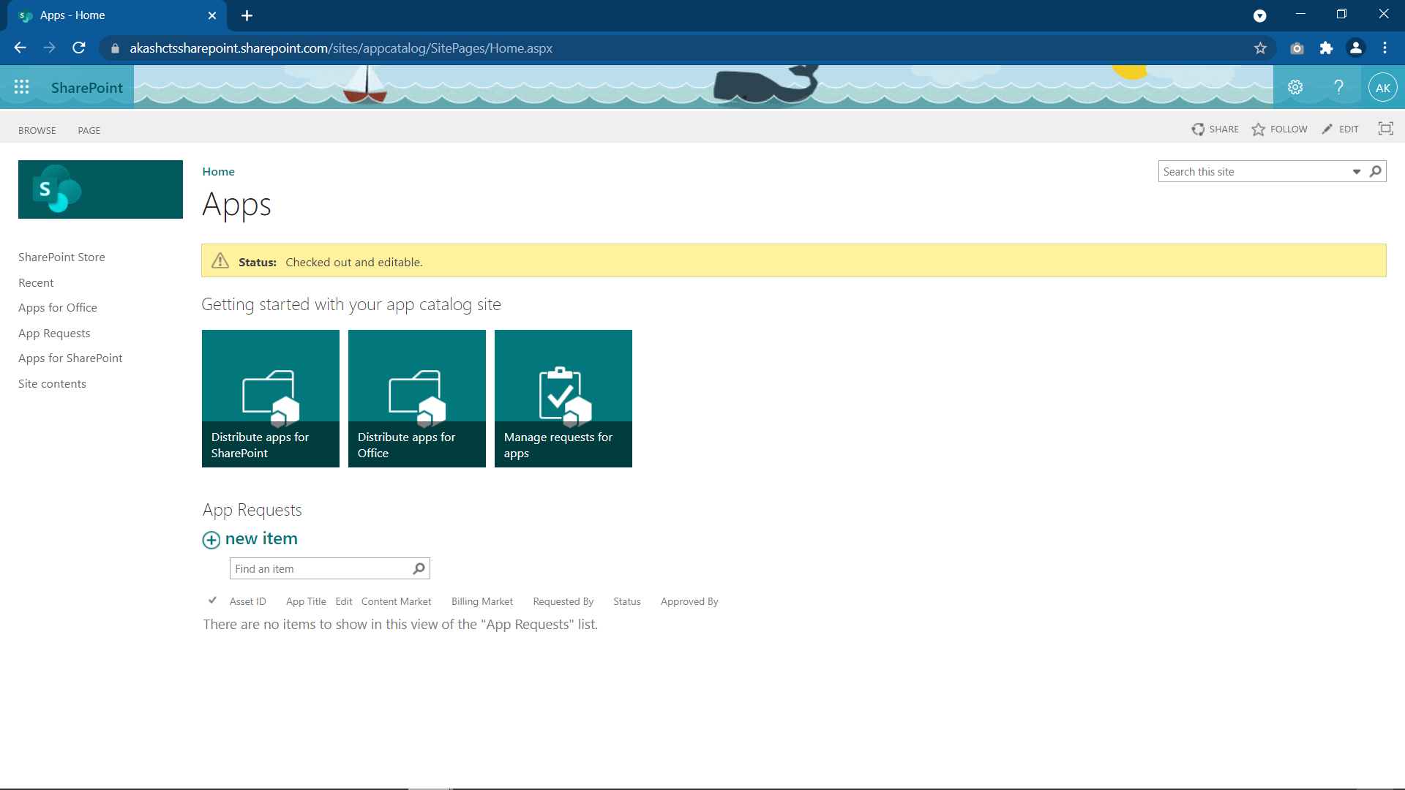

Click Distribute Apps for SharePoint and now upload the .sppkg file here

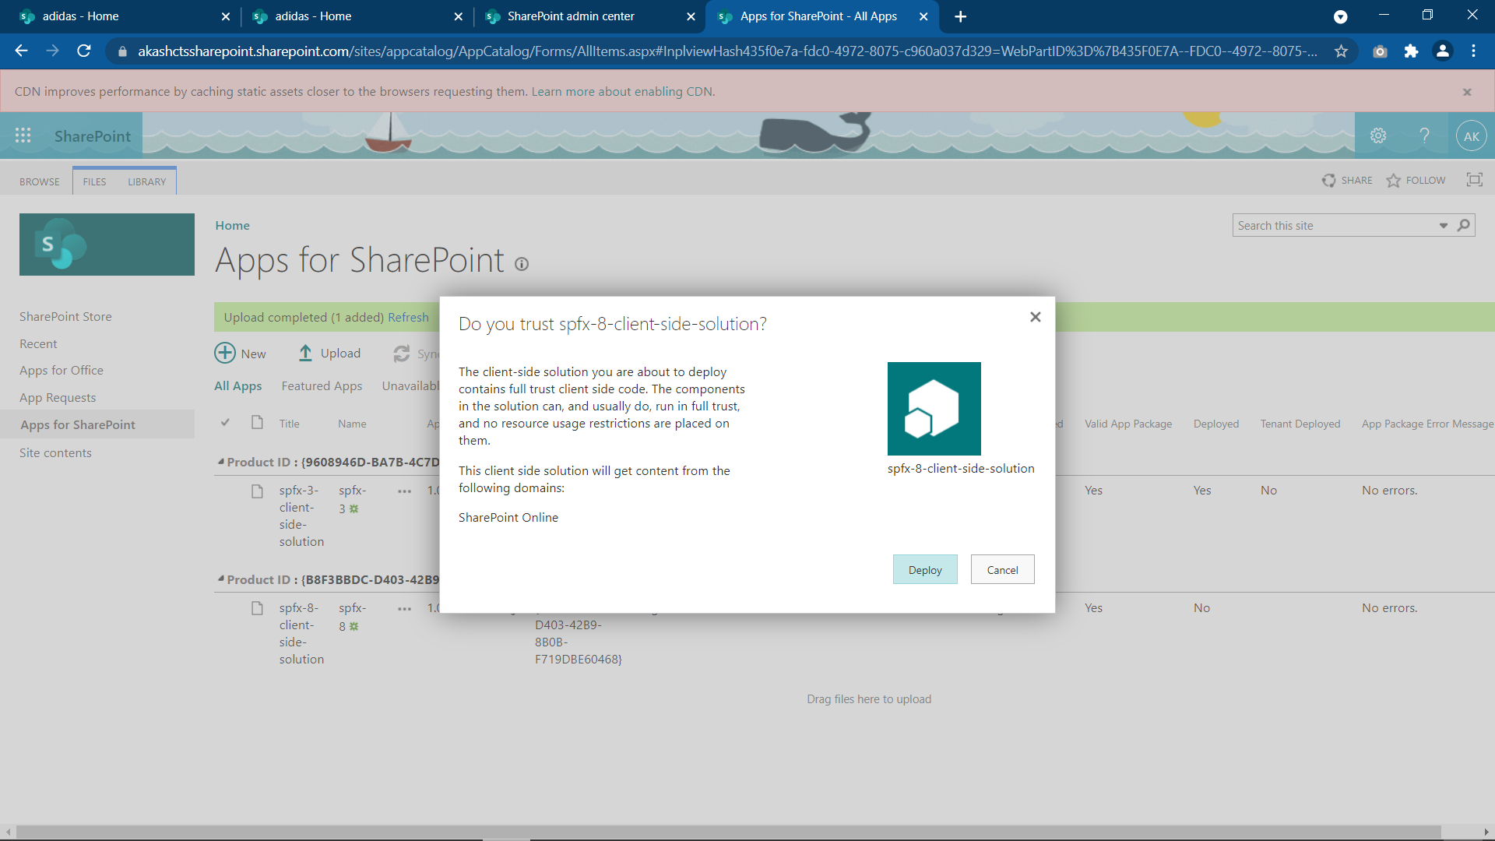

Click Deploy , now the .sppkg must appear in the list

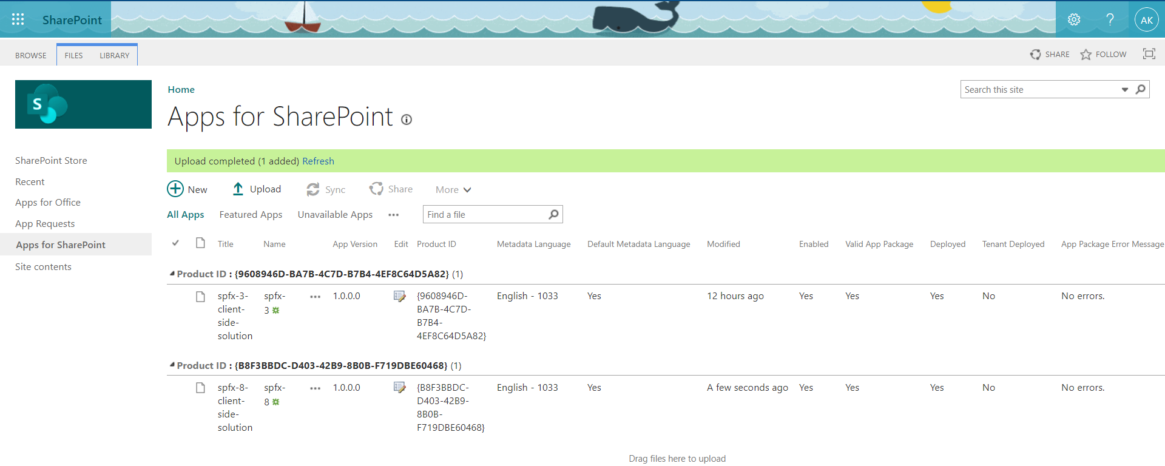

Now go to the site in which we want to use this extension, go to site content -> +New -> Apps

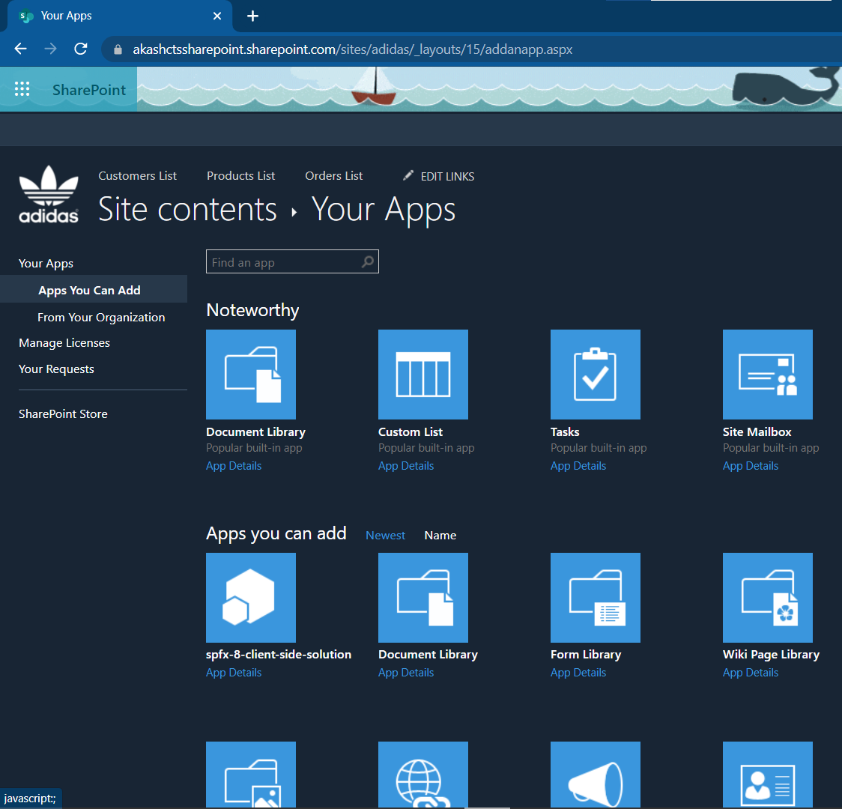

Here you can see your webpart,

by clicking you will add in the site content of that site

## 4. Configure Navigation – Both Top Navigation & Quick Launch Navigation as required, add appropriate links to navigate to Sales Order Form, Product, Customer & Order Lists, Reports

To add links in the top navigation, got to Site Contents -> Site settings -> Edit Links(on top)

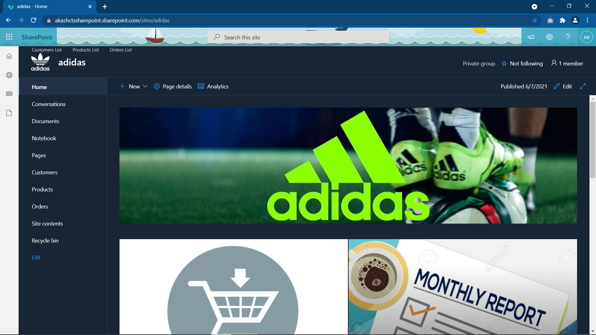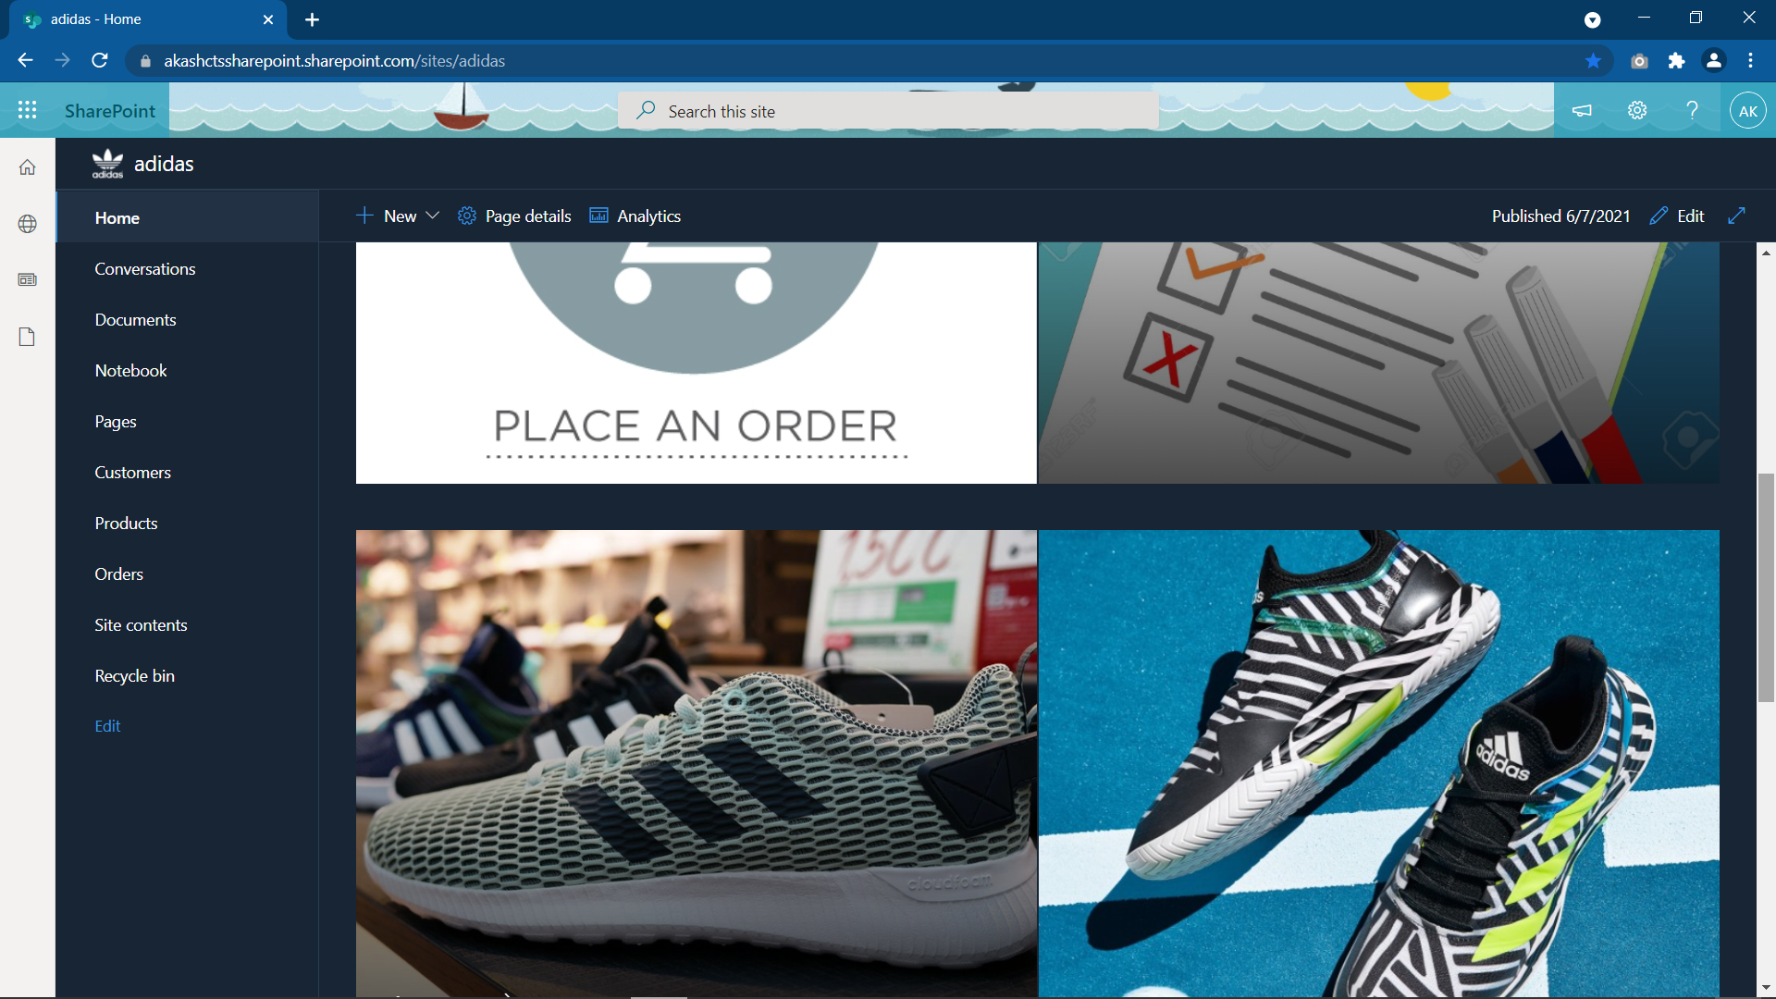

**Order Form**

**Excel Sheet of monthly report**

To add link in the form of an clickable image, add the Hero webpart on the page

Click on Edit -> + -> Hero

add an image and a link to the given tile

## 5. OOB Custom Views – Based on Customer Name, Product Name, Sales Value > 10

Default View : All View

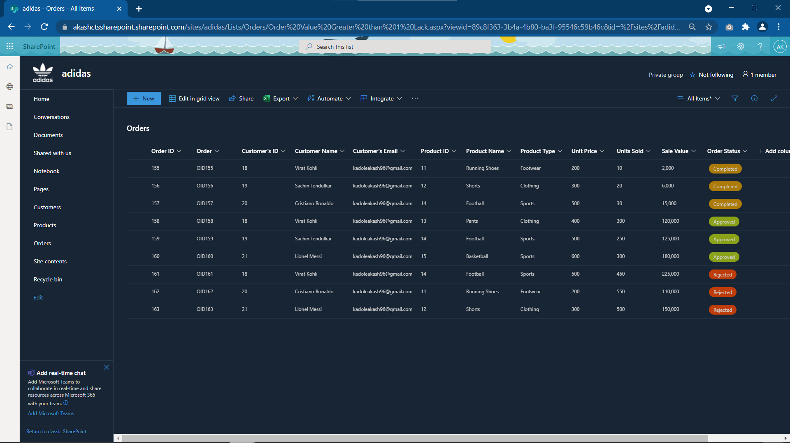

View 1 : Order Values > 100,000

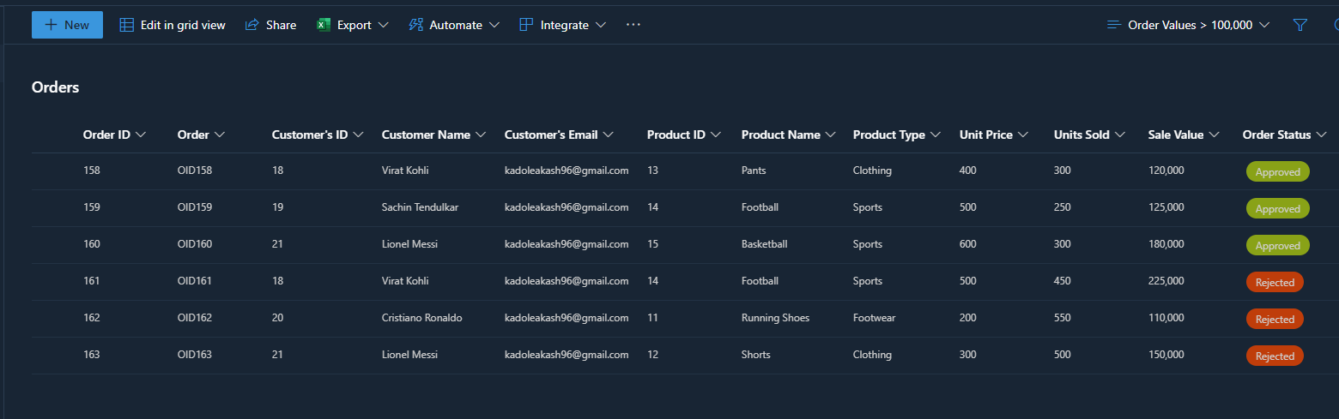

View 2 : Approved Items

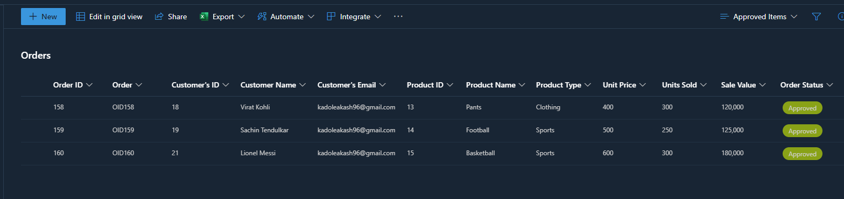

View 3 : Rejected Items

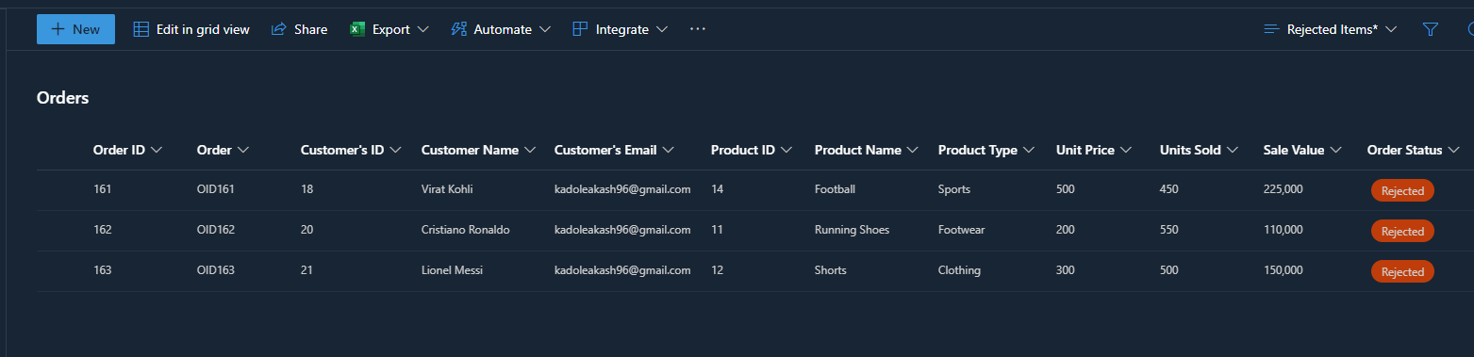

View 4 : Customers Grouped

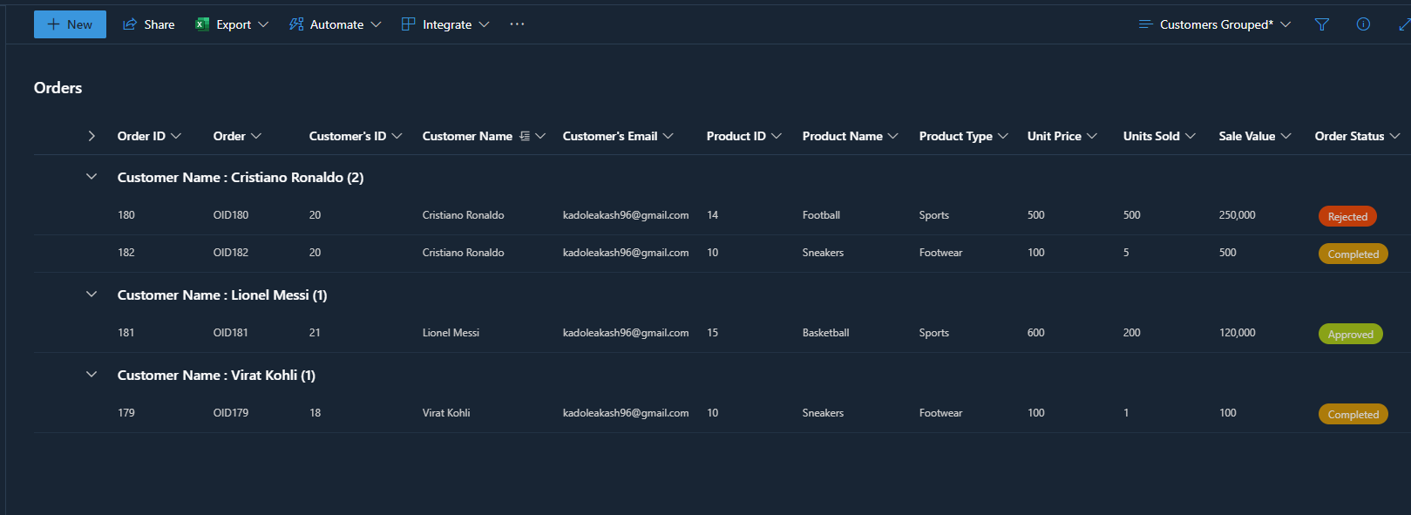

View 5 : Products Grouped

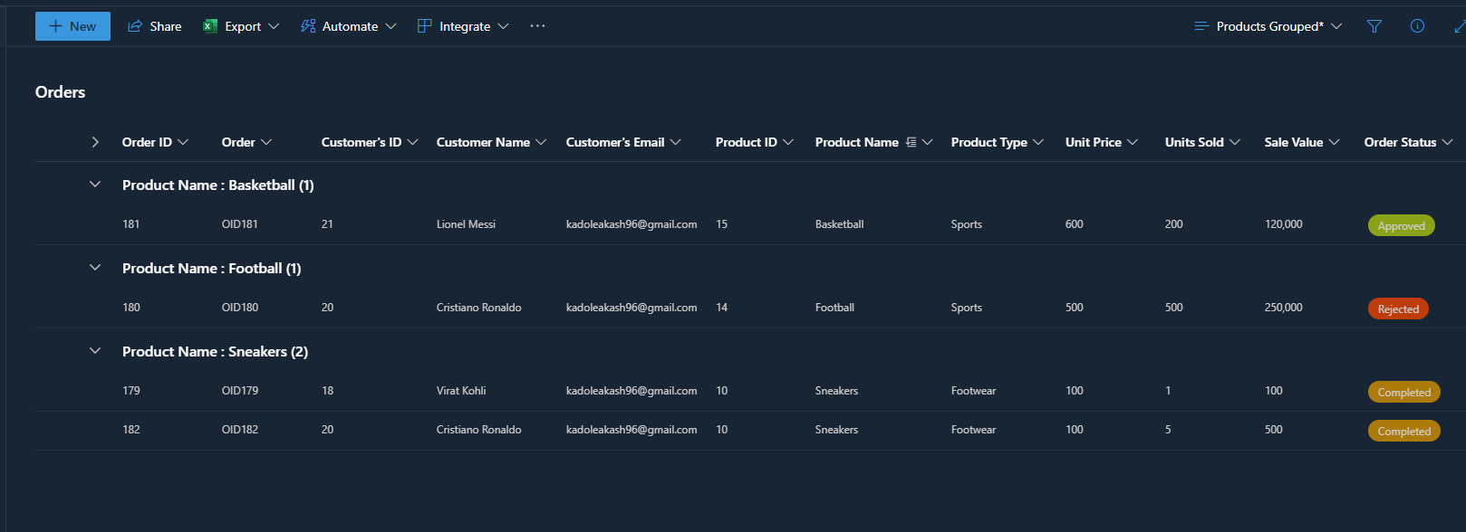

## 6. Add appropriate validation using UsePreSaveAction in all OOB Lists and JavaScript/ JQuery validations on client side

In Modern Site, there are 2 ways for adding validation to a form

* PowerApps
* columnValidation settings (while creating columns in a list)

PowerApps method for list Customer & Products

Open the list -> +New -> Edit Form -> Choose Customize with Power Apps

Customer List Form

All fields required Name Validation Email Validation No Errors - Submit

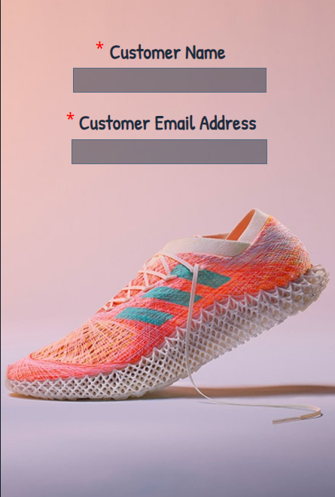 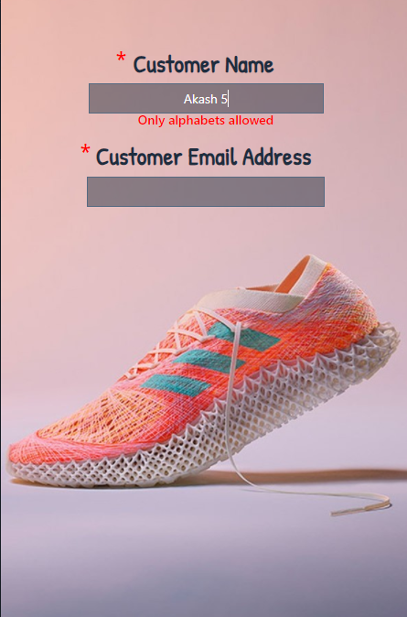 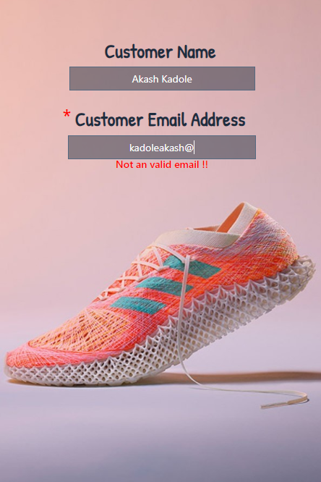 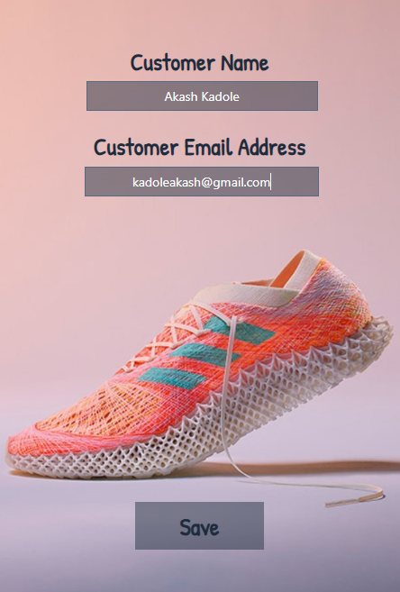

All fields required Name Validation Unit Price Validation Date Validation

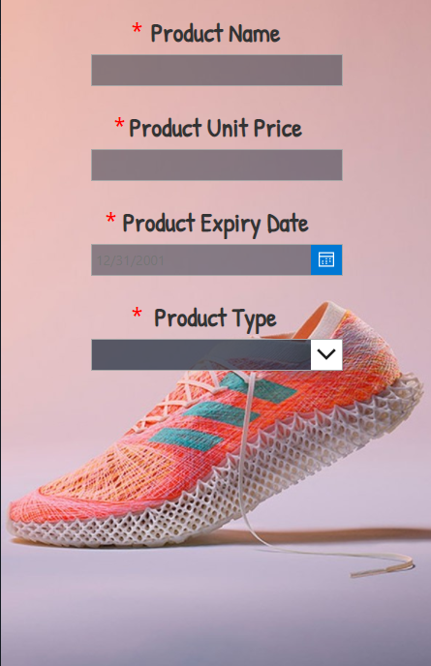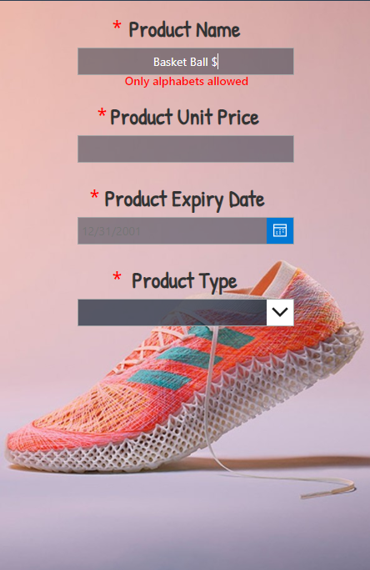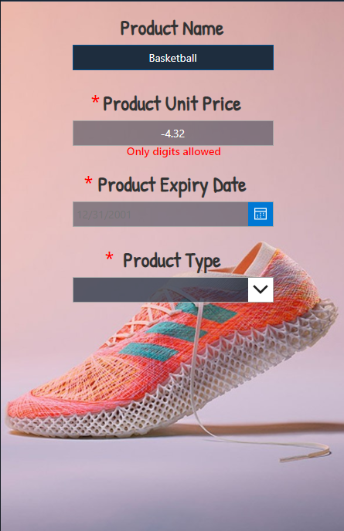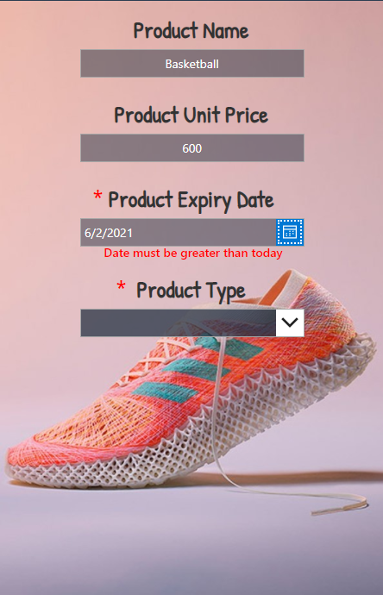

**Type Validation** No Errors - Submit

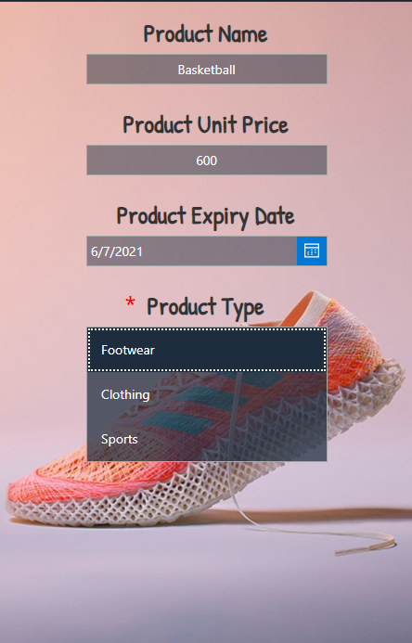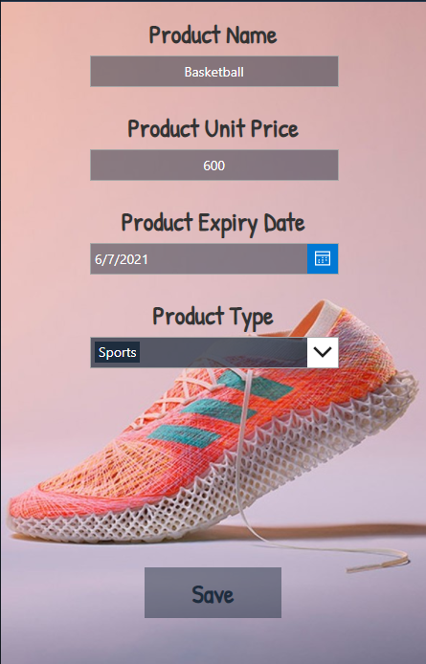

**Product List Form**

## 7. Build a SPFx webpart with ReactJS UI to make the order entries which will have the following UI fields with Header and Footer

1. Customer Name: (Dropdown list which gets data from customer list)
2. Product Name: (Dropdown list which will display all the products)
3. Product Type – Auto populate based on selected product name field
4. Product Expiry date – Auto populate based on selected product name field
5. Product Unit value – Auto populate based on selected product name field
6. Number of Units – Text box that accepts only numeric values
7. Sale value – Calculated based on Number of Units (*) Unit value
8. **Add Button**– To add the order to **Orders**list
9. **Edit Button** – To edit the orders by passing Order ID
10. **Delete Button** – To Delete Orders by passing Order ID
11. **Reset Button** – To Clear all values after Insert, update operations

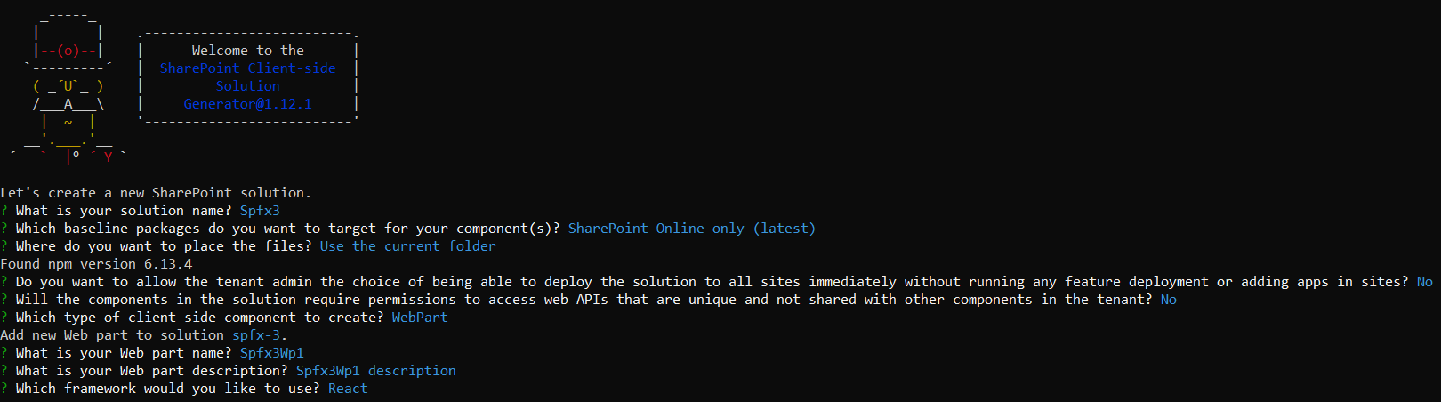

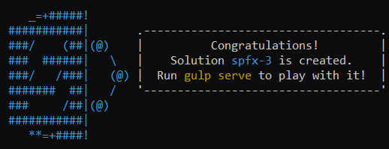

Now write your code into the component folder & test it in the workbench

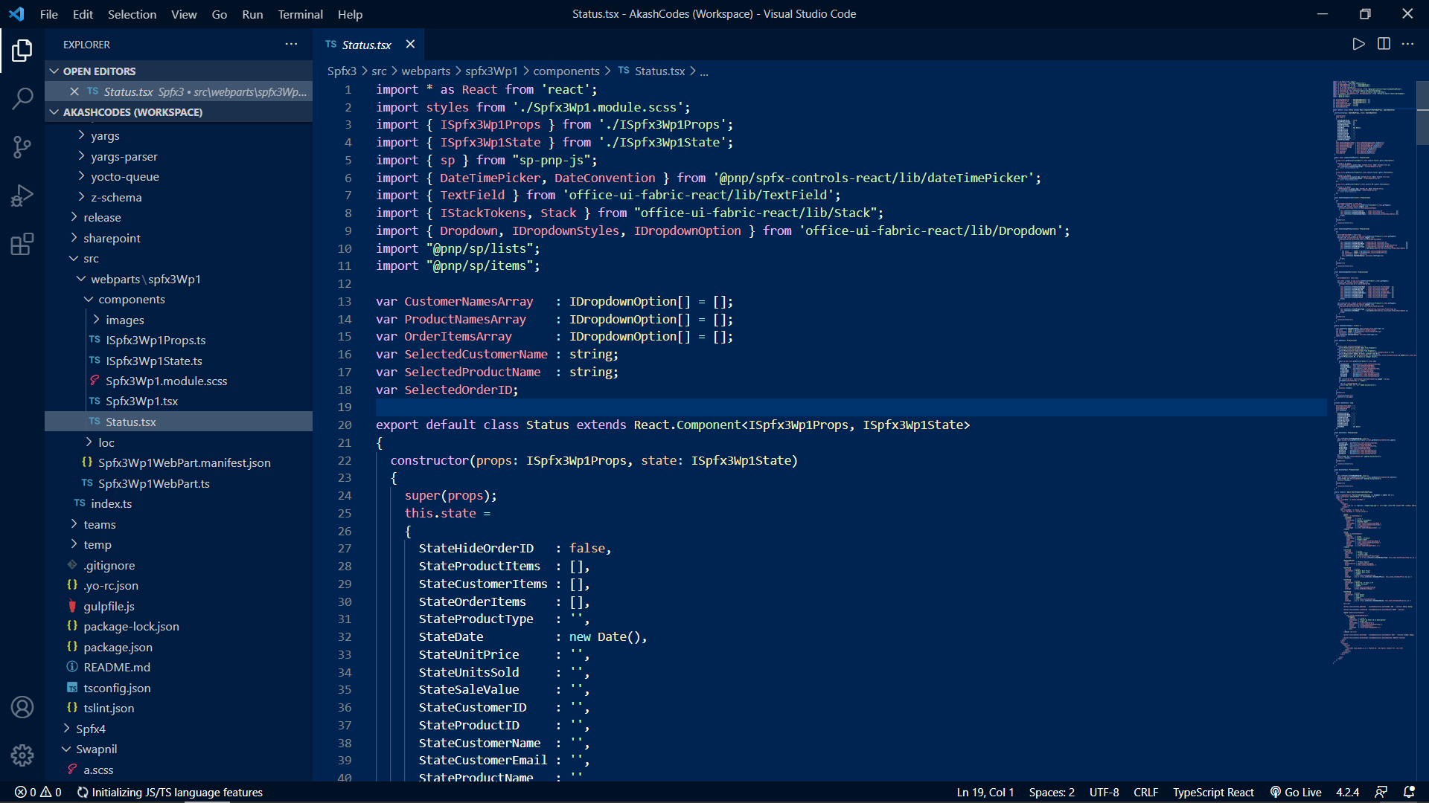

After fully testing in the workbench we can deploy the webpart

Deploying Phase :

to deploy the webpart run the 4 gulp commands in given sequence

gulp clean , gulp build , gulp bundle --ship , gulp package-solution --ship to create .sppkg file

Now a .sppkg file has been created within the folder ./sharepoint/solution/spfx-3.sppkg

Now go to your SharePoint Admin Canter -> More Features -> Apps(open) -> App Catalog



Click Distribute Apps for SharePoint and now upload the .sppkg file here

Click Deploy , now the .sppkg must appear in the list

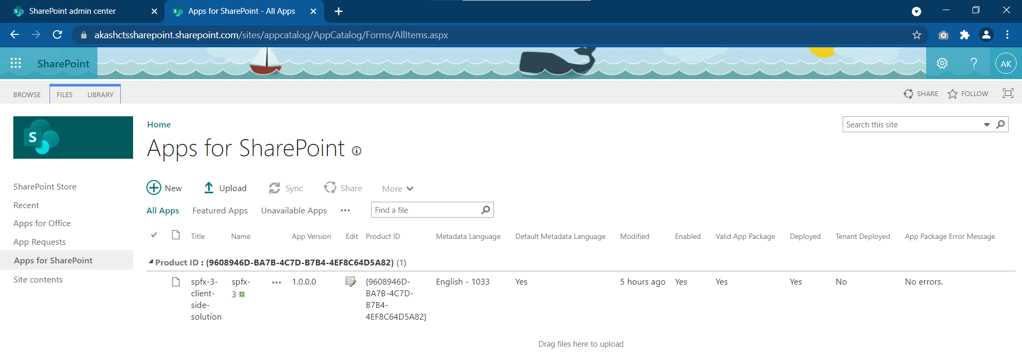

Now go to the site in which we want to use this webpart, go to site content -> +New -> Apps

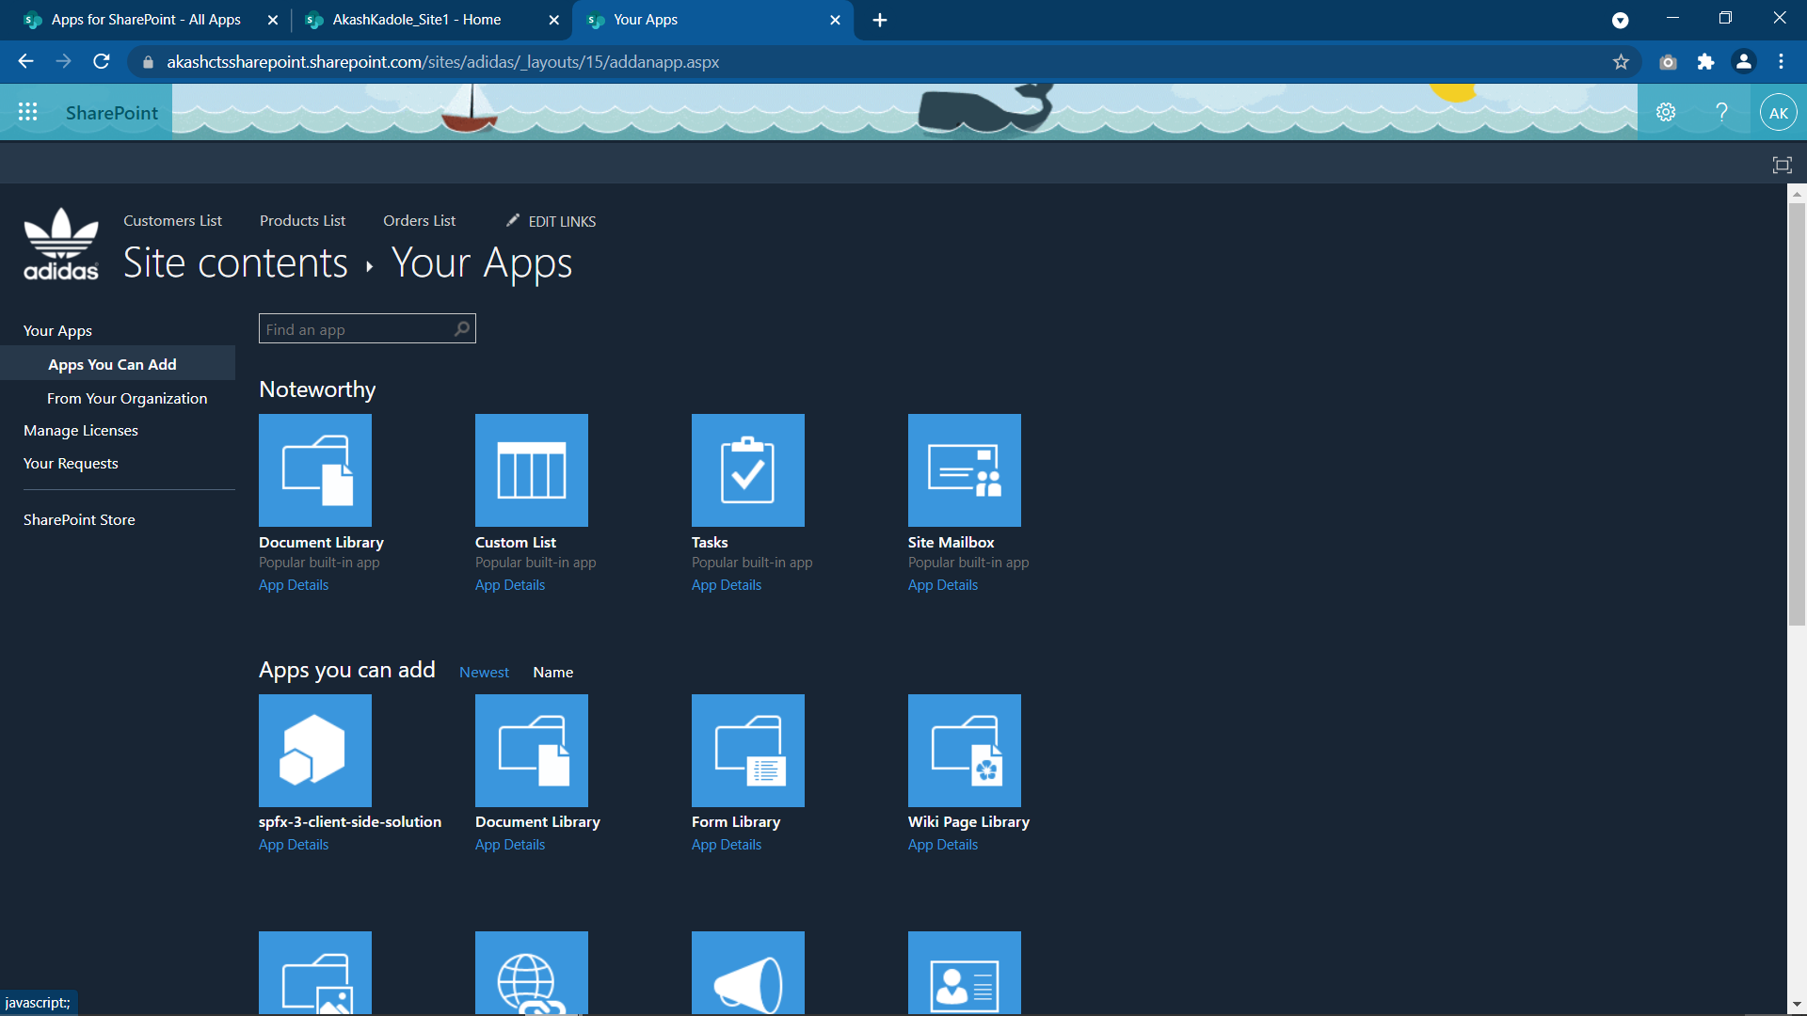

Here you can see your webpart,

by clicking you will add in the site content of that site

Now after adding this webpart, simply create a new web part page by going in :

Site Content -> Site Pages -> +New -> Webpart page

Now click on edit page -> add a webpart , then from Categories -> Others -> Spfx3Wp1 -> Add

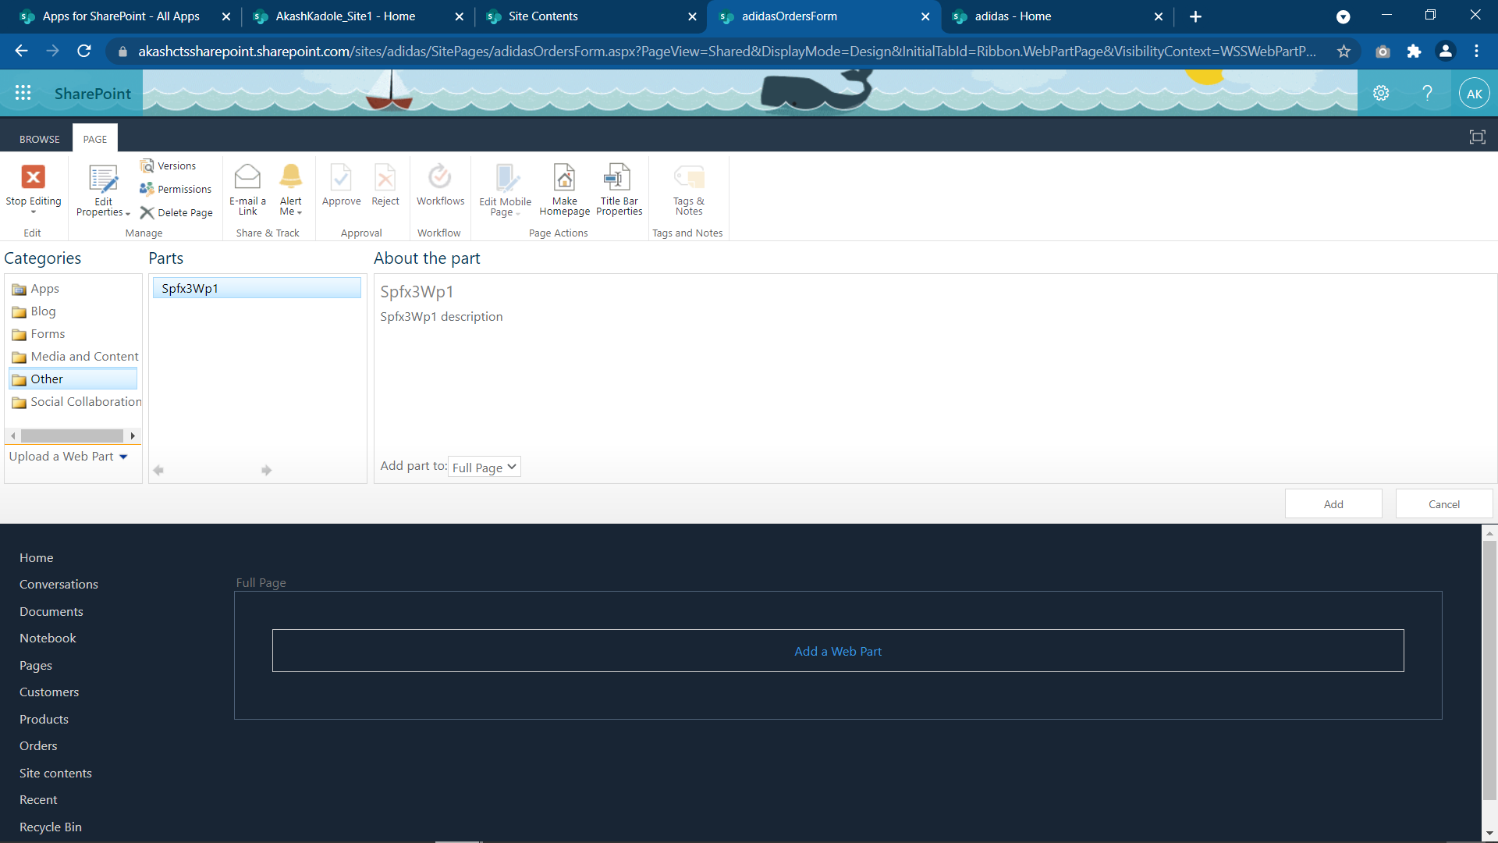

## 8. Create 2 security groups in the site

* Administrator – Should be able to add/edit/delete records in all the lists
* Sales User/Manager – Will have read access to customer and Product, Contribution access to Orders list

Go to settings -> site permissions -> Create Group

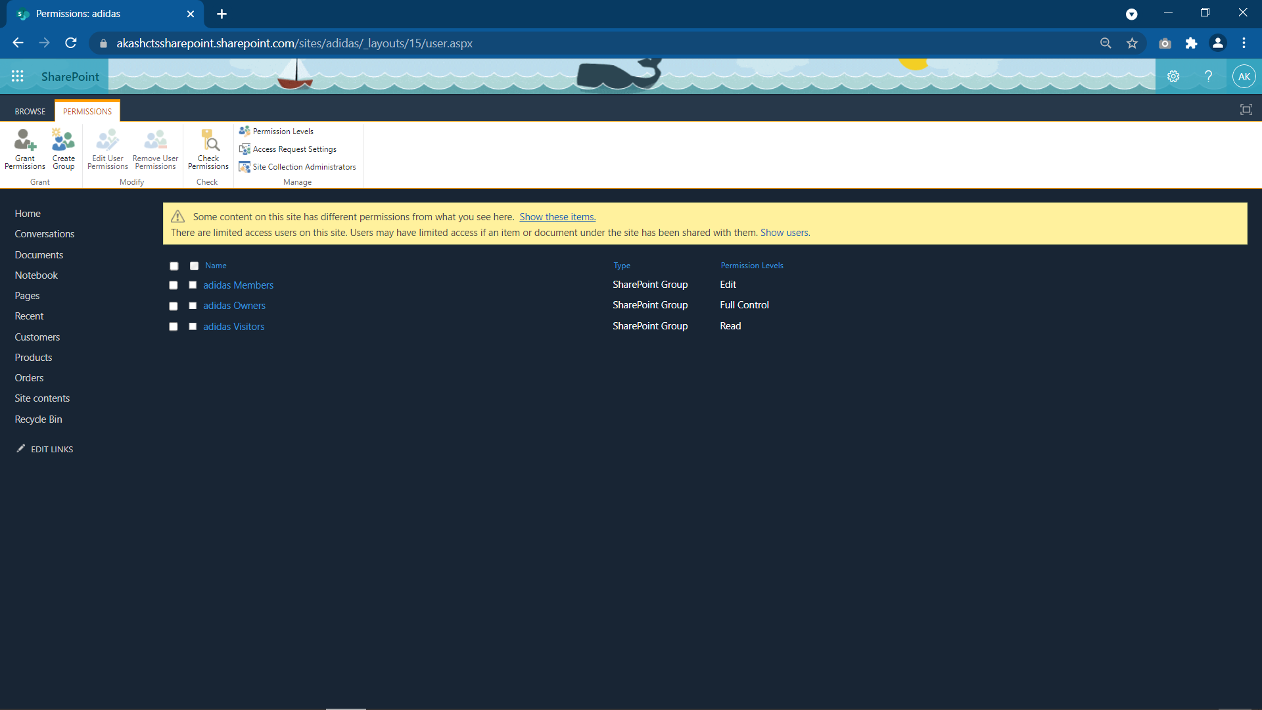

Now create a group Adidas Administrator with permission level Full Control

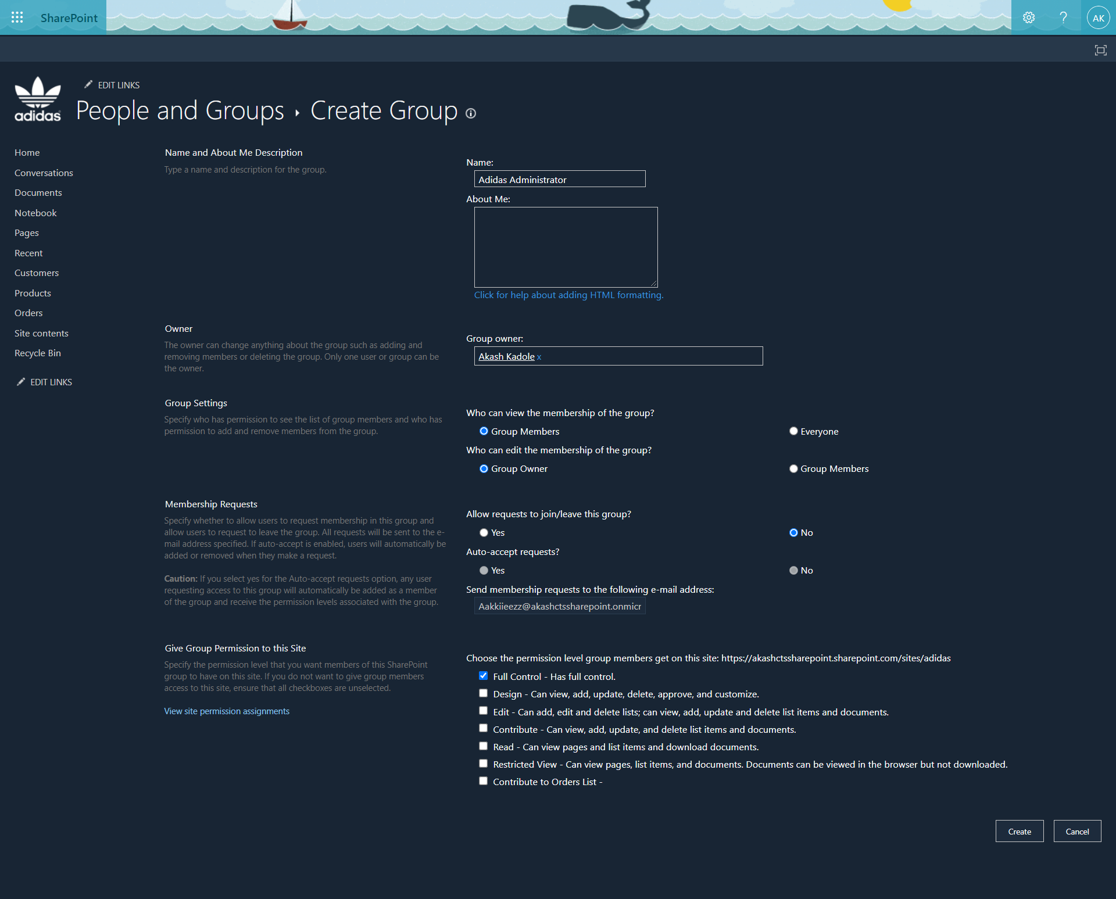

Now to add custom specific list permission go to each list -> List Settings -> Permissions for the list -> Grant Permissions

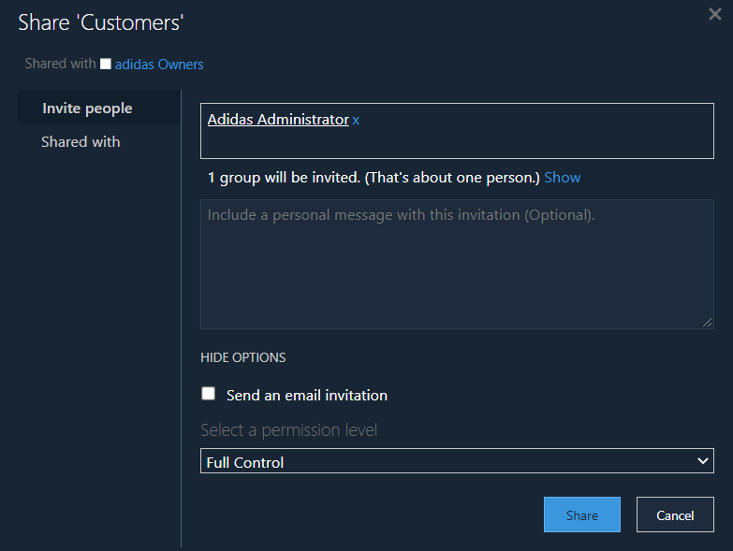 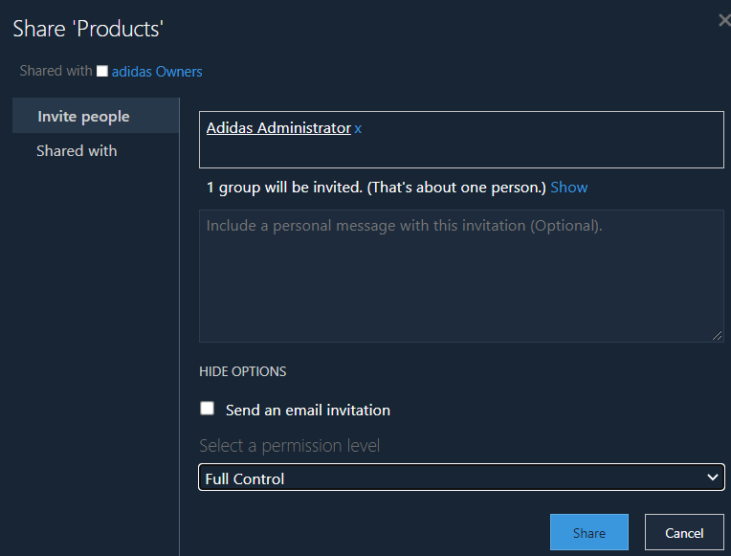

Customers List – Full Control Products List – Full Control

Orders List – Full Control

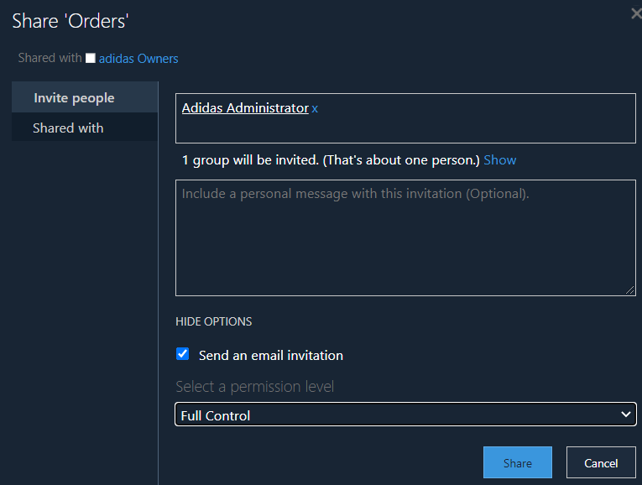

Create another group Sales Manager with no permission levels

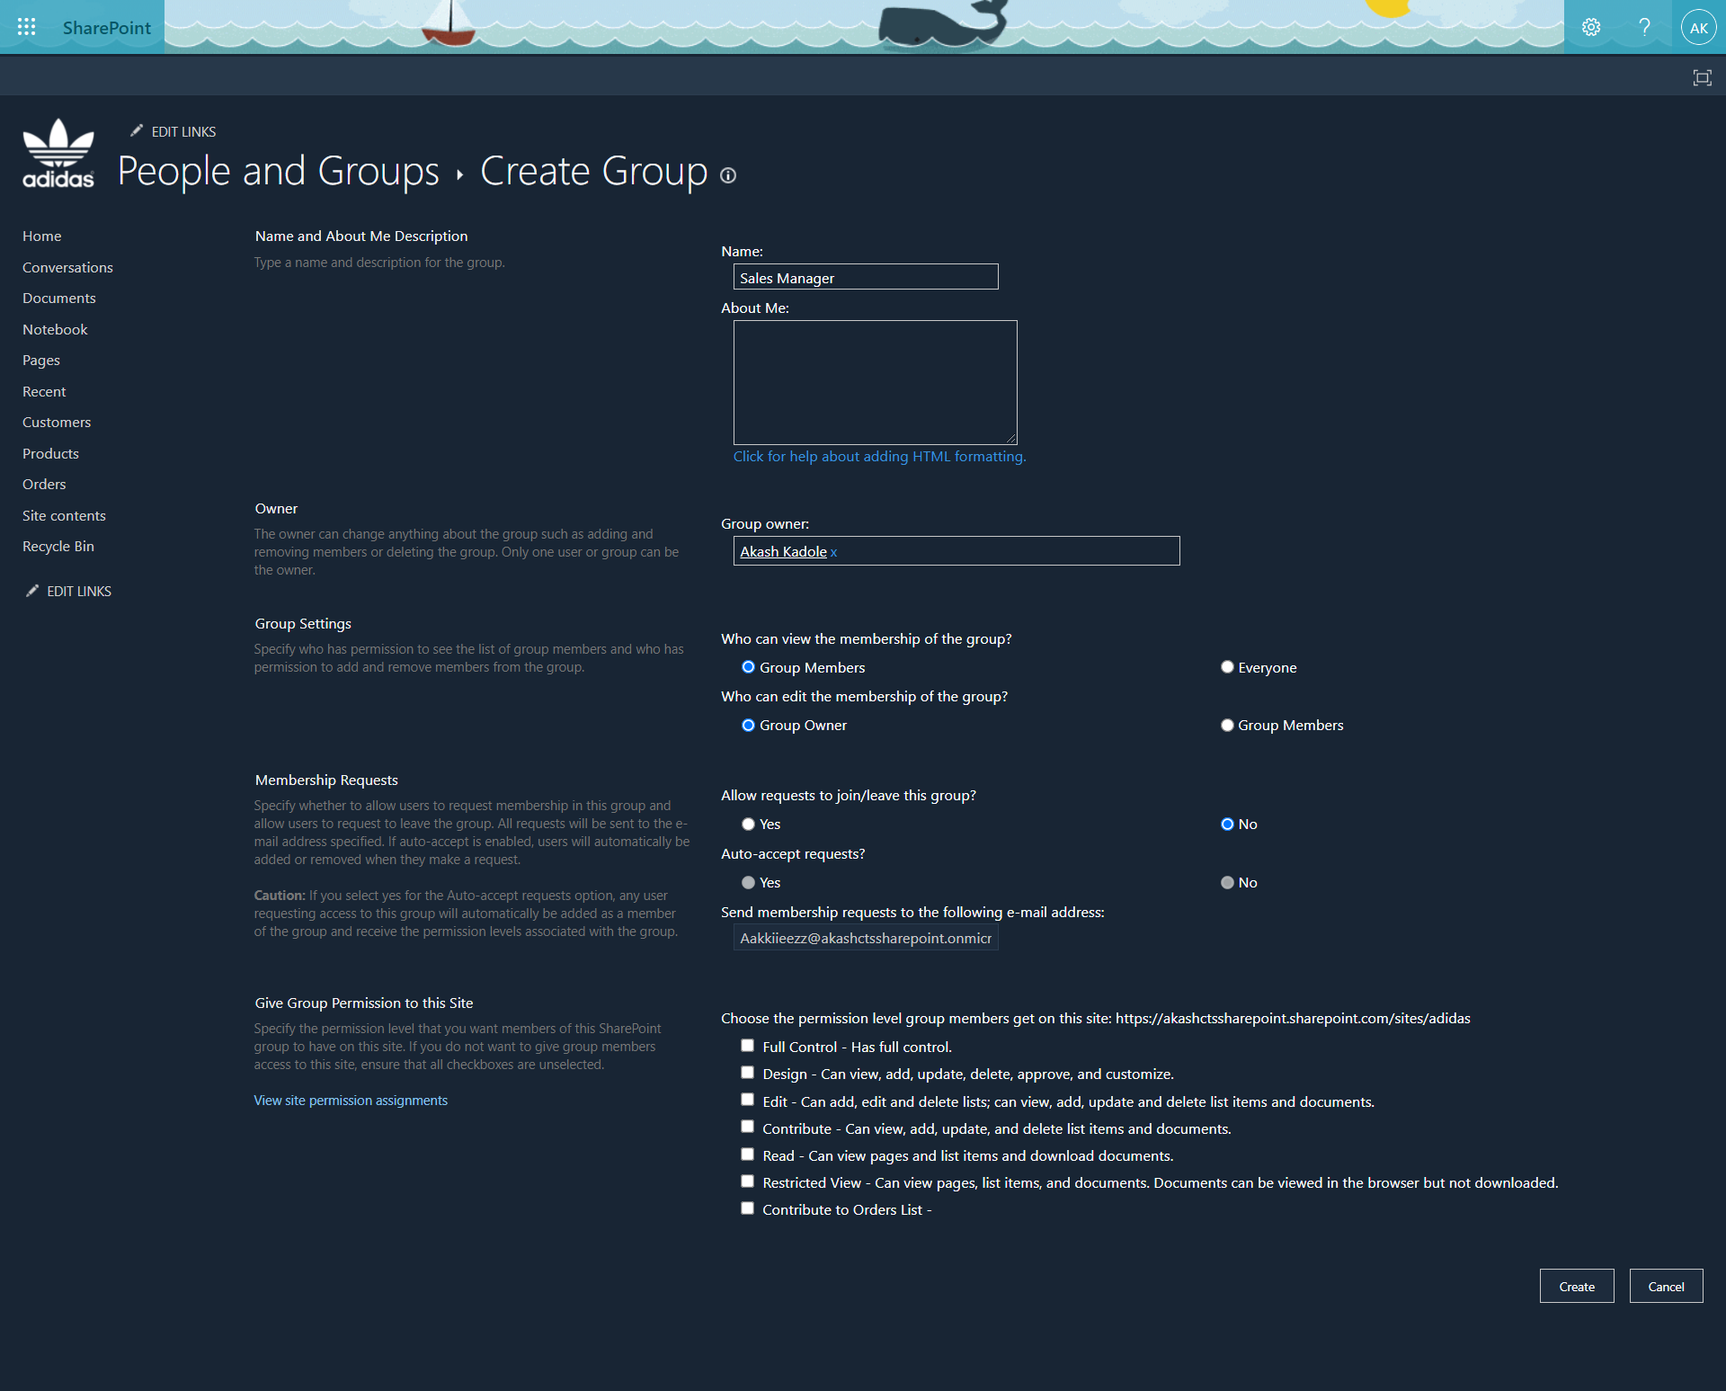

Now to add custom specific list permission go to each list -> List Settings -> Permissions for the list -> Grant Permissions

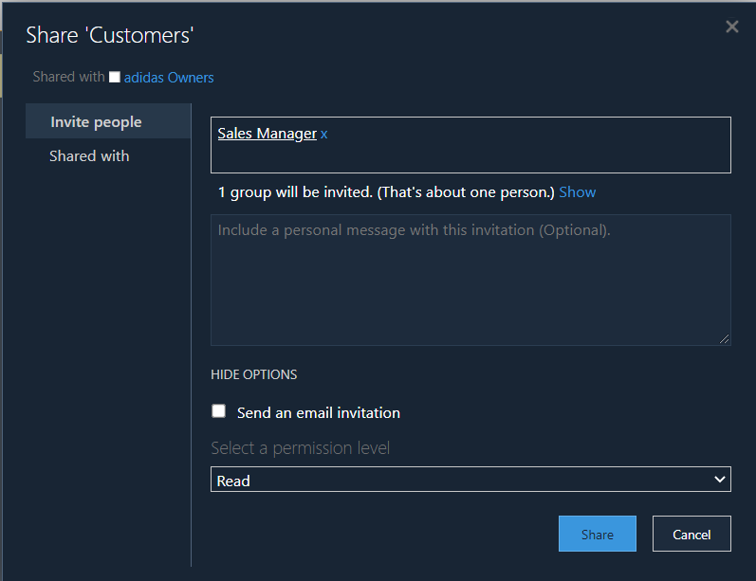 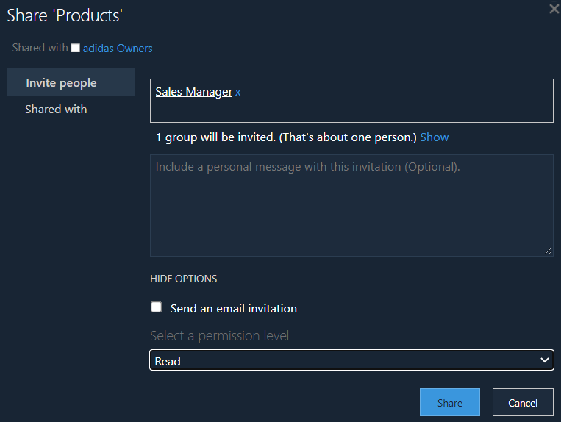

Customers List – Only Read Products List – Only Read

Orders List – Contribute

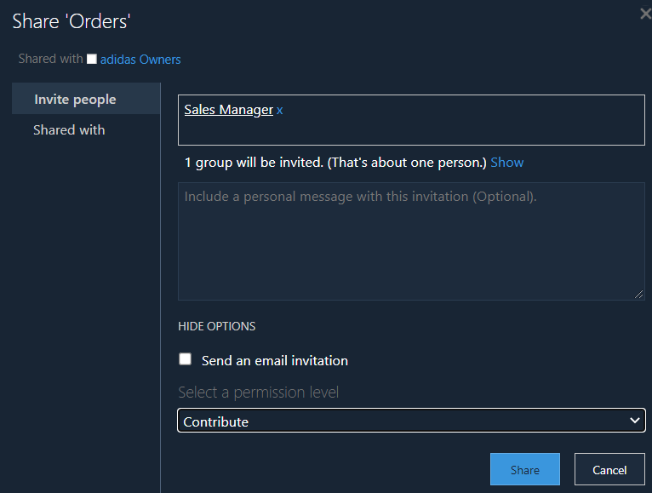

## 9. Send mail to Sales users using Flow (Power Automate)

* Send mail to Sales Manager, Customer E-Mail for each Sales order (Invoice Format)
* Approval for Sales order value more than 1,00,000, update the status in orders list as Approved, Point 1 send invoice and update status as completed
* Generate summary report of monthly sales in excel format

Go to India.flow.microsoft.com, then click +Create and search for When an item is created template

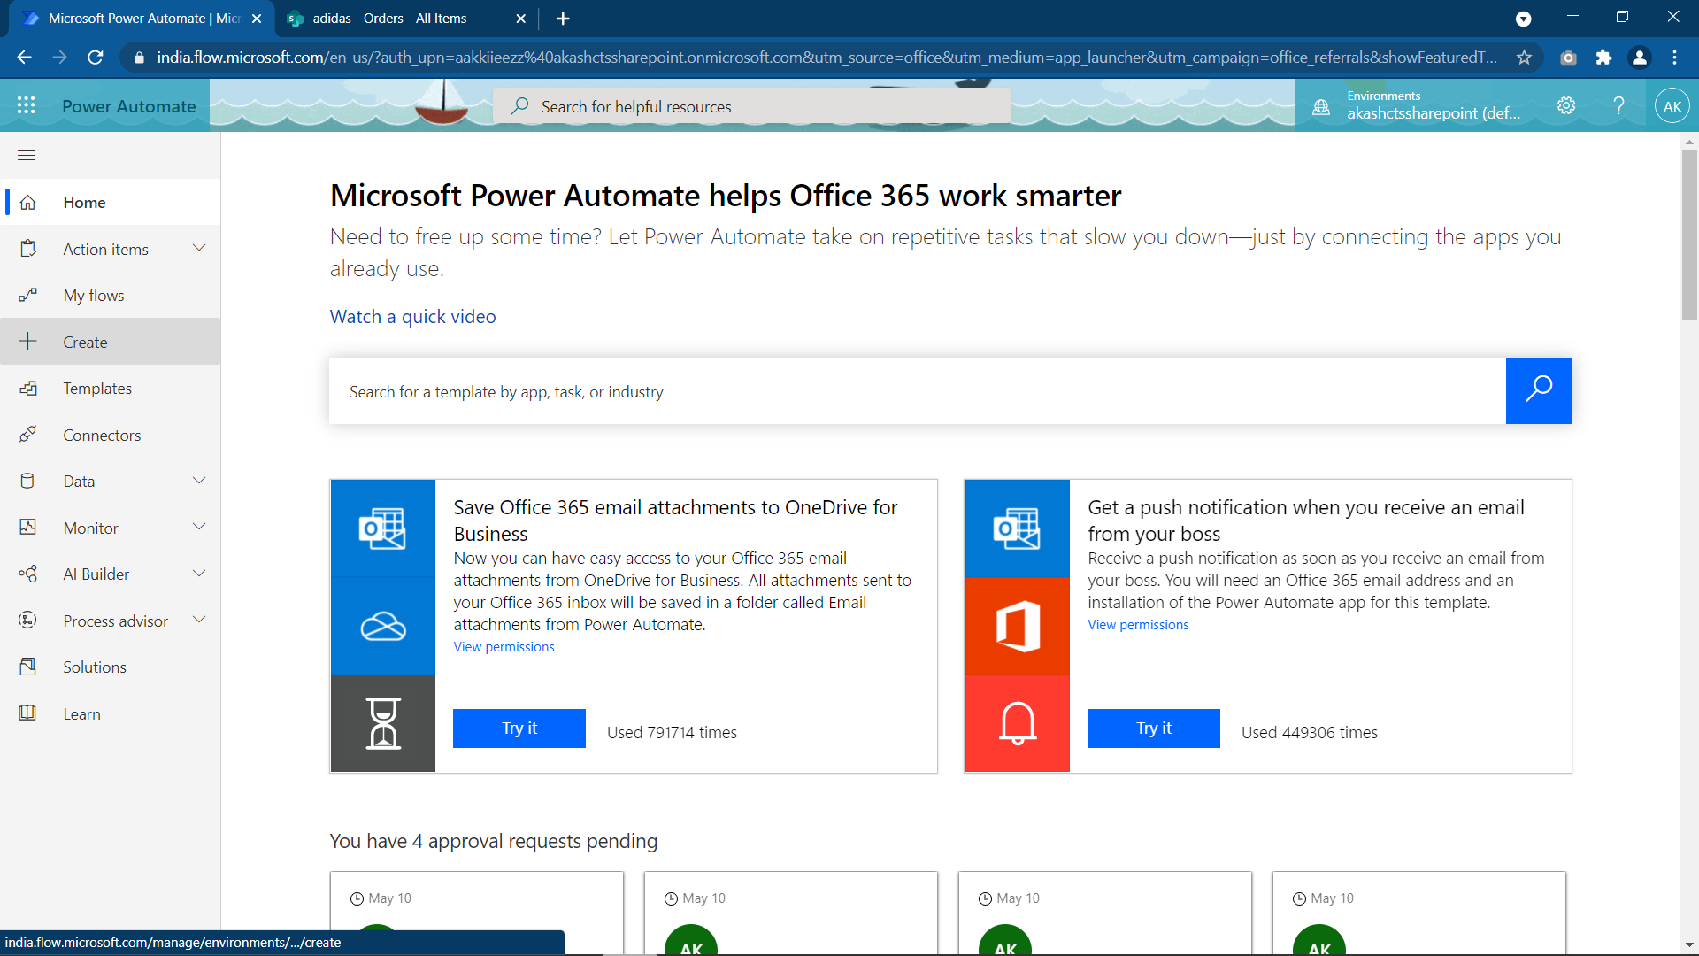

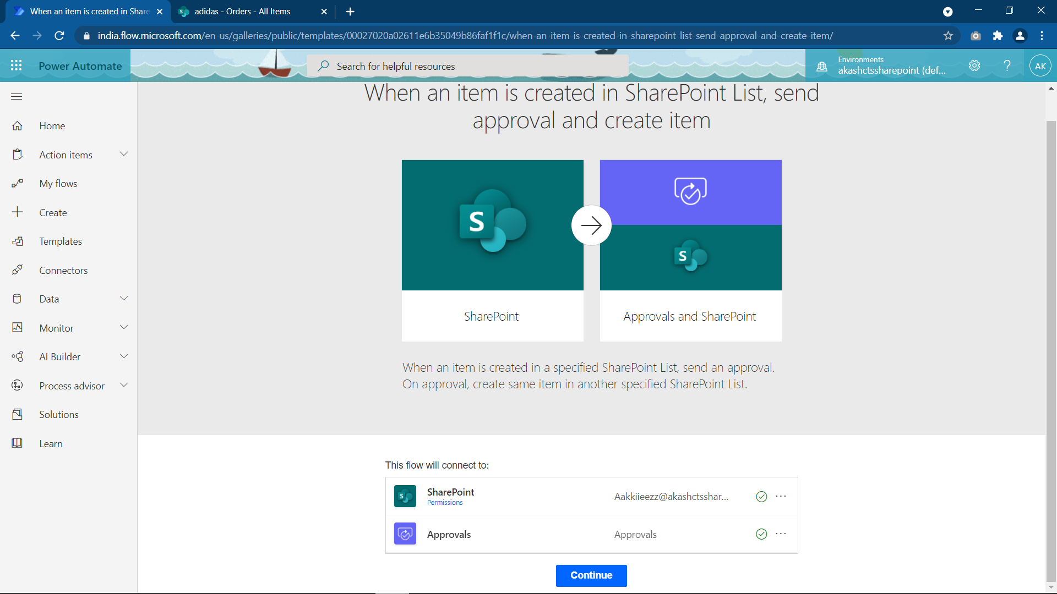

Flow in short :

if(SaleValue < 100000)

OrderStatus = Completed

Email to customer (with Invoice)

if(SaleValue > 100000)

Email to sales user (to Approve/Reject)

if(Approved)

OrderStatus = Approved

Email to customer (with Invoice)

if(Rejected)

OrderStatus = Rejected

Email to customer

Now create the flow

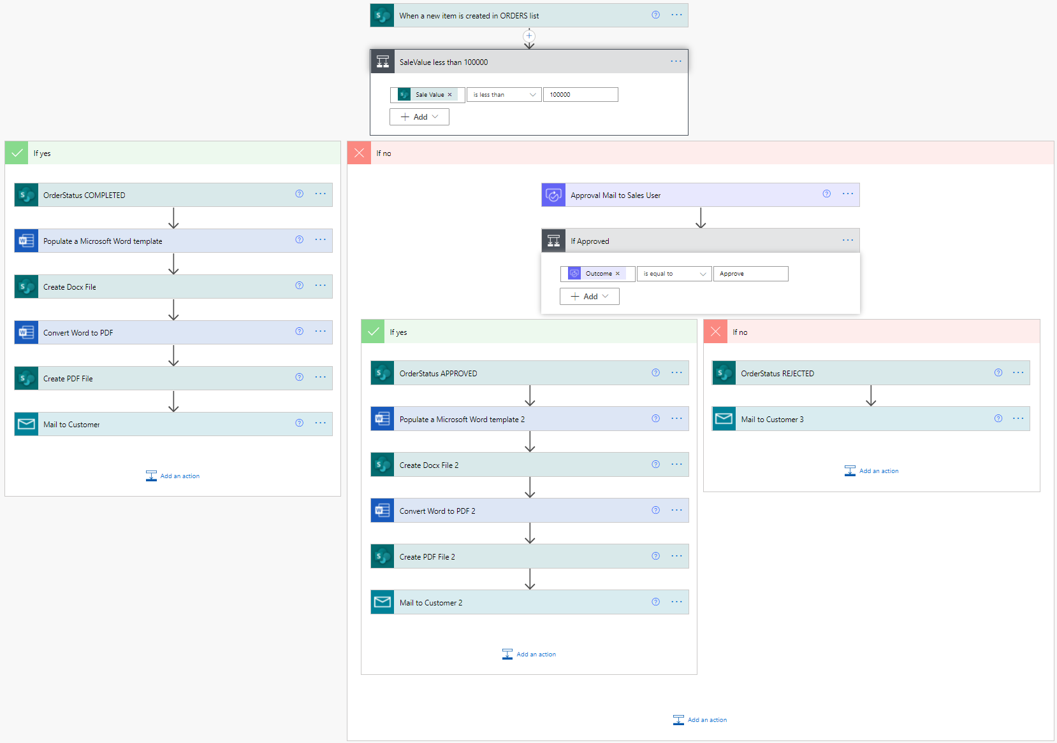

Lets try the flow with 3 tests :

1. (Sale Value < 10000) : Customer Email (with invoice) + Order Status Completed
2. (Sale Value > 10000) & (Approved by sale manager) : Customer Email (with invoice) + Order Status Approved
3. (Sale Value > 10000) & (Rejected by sale manager) : Customer Email + Order Status Rejected

**Case 1** : (Sale Value < 10000) : Customer Email (with invoice) + Order Status Completed

Updated

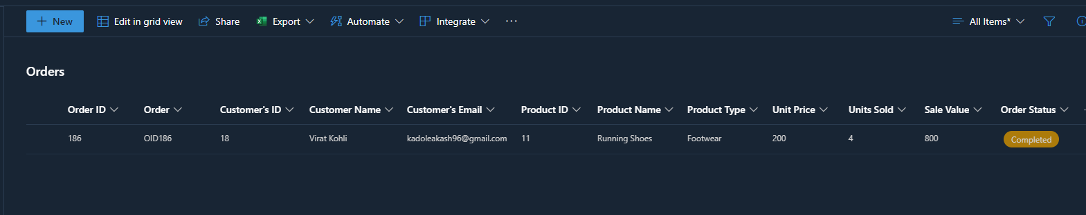

Email Invoice

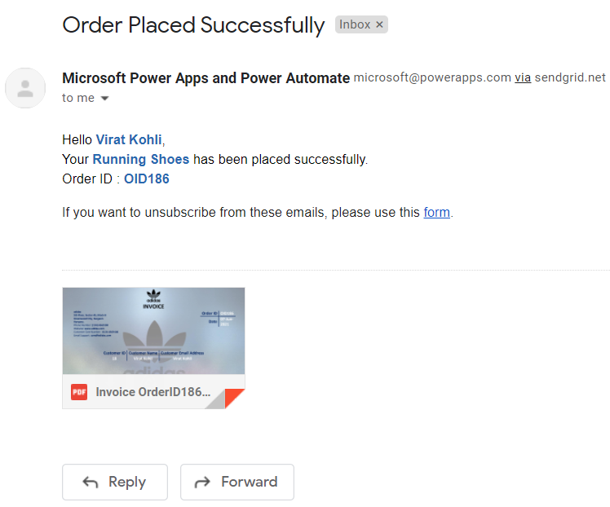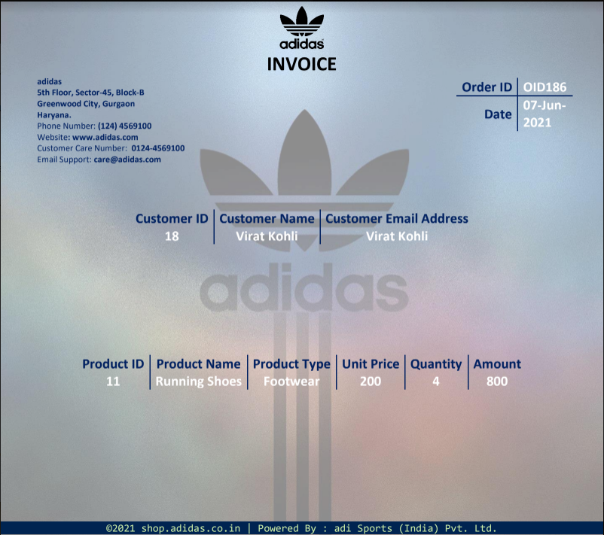

**Case 2** : (Sale Value > 10000) & (Approved by sale manager) : Customer Email (with invoice) + Order Status Approved

Updated

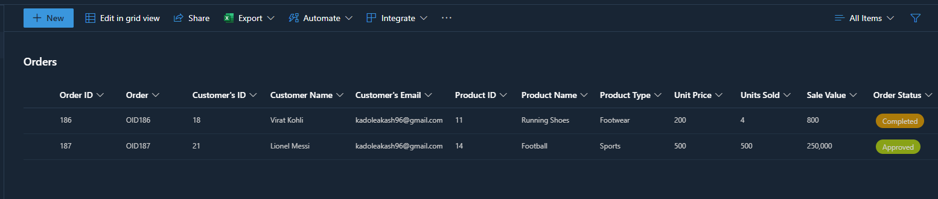

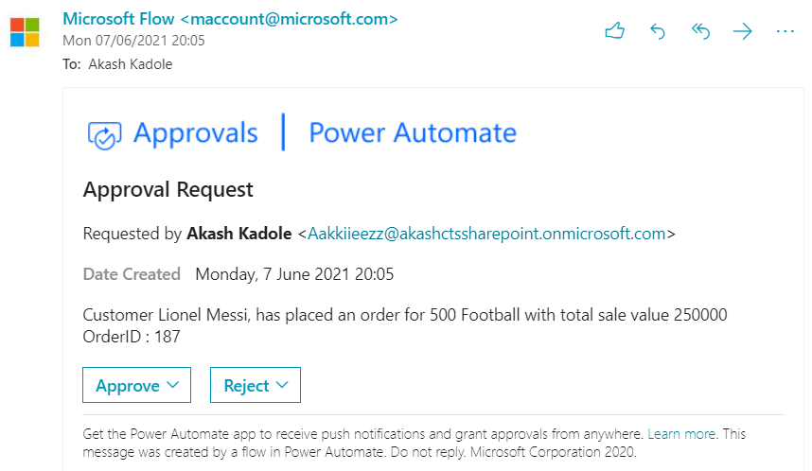

Approval Mail

Email Invoice

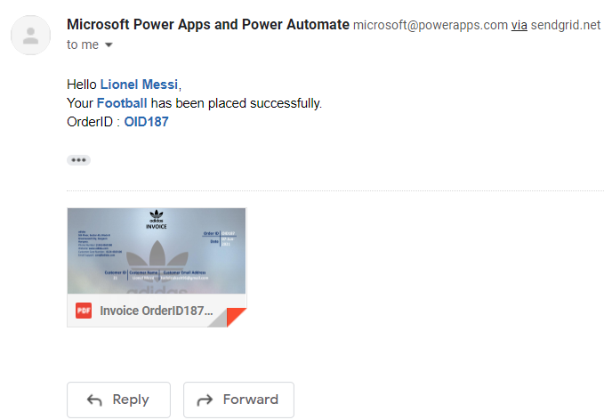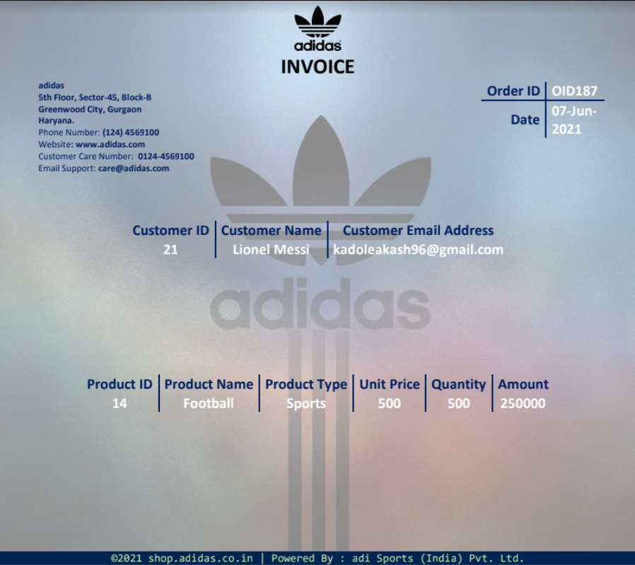

**Case 3** : (Sale Value > 10000) & (Rejected by sale manager) : Customer Email (with invoice) + Order Status Rejected

Updated

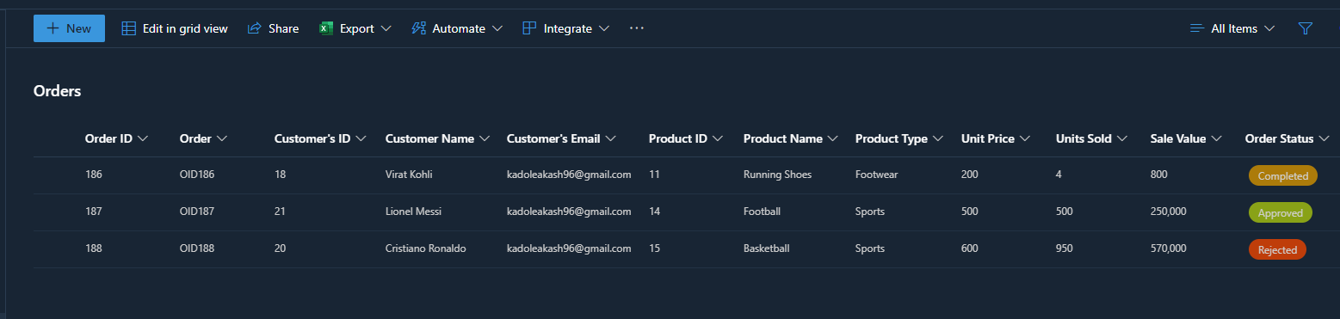

Approval Mail Email

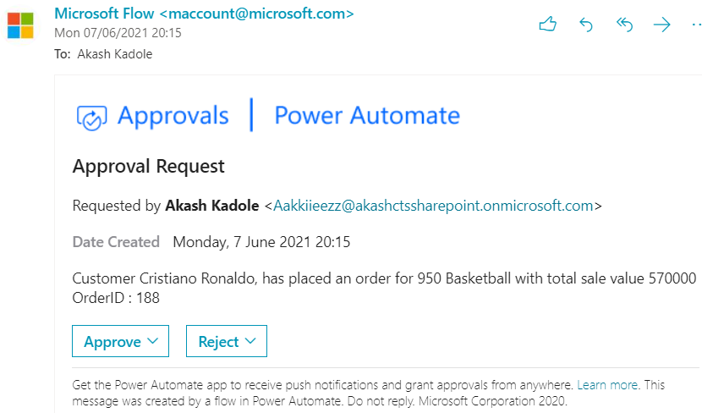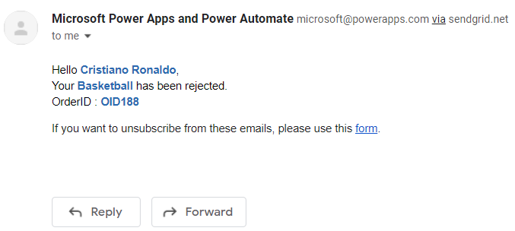

For monthly sales in excel, we have to create another flow  
Go to India.flow.microsoft.com, then click +Create and search for Create SharePoint item for Excel template

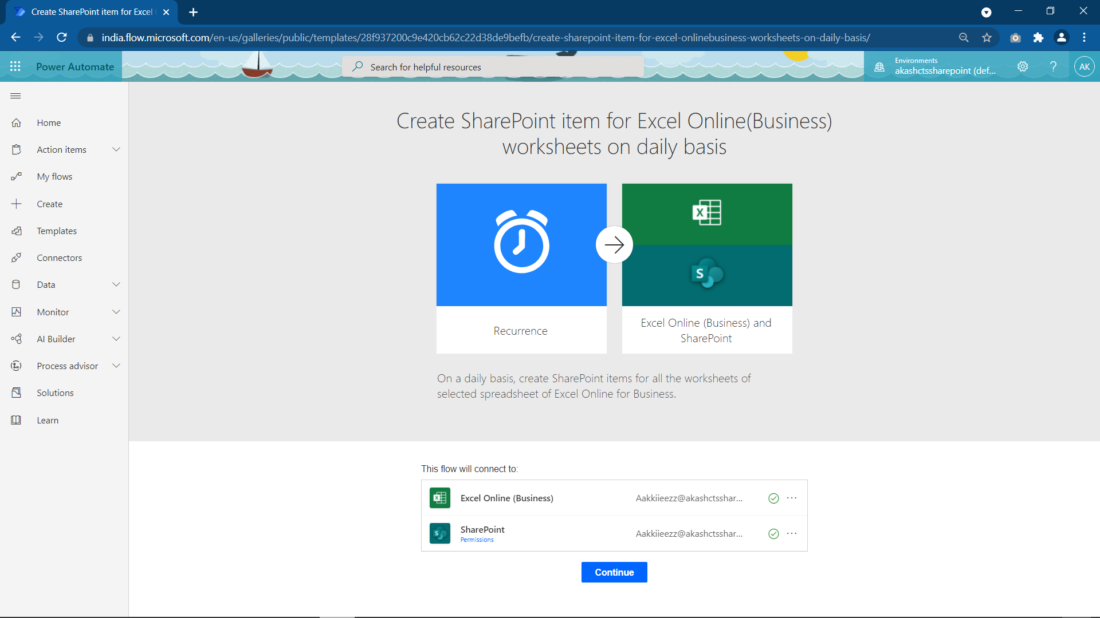

Now create the flow

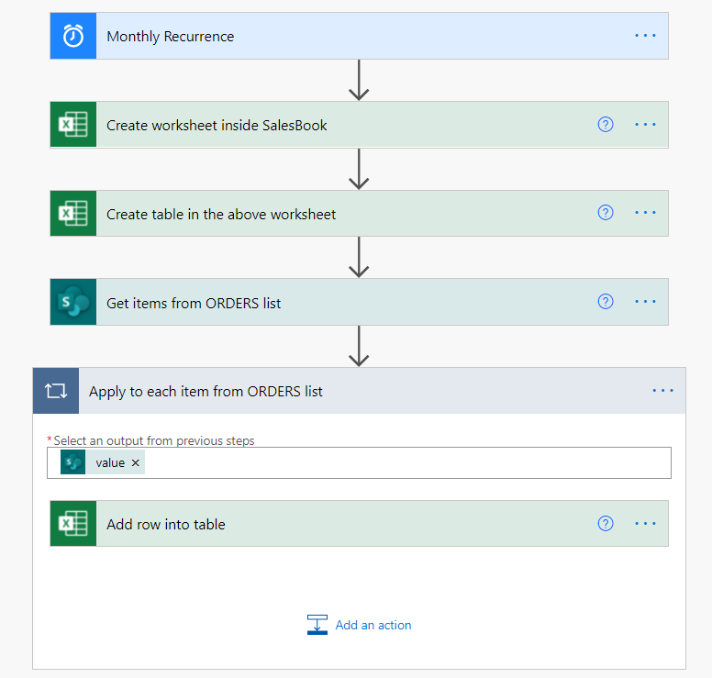

Lets Test the 2nd Flow :

All List Items



Monthly Sales Report in excel format

